
adatneo±
dddfld, — 580025

'a' dndd
Zoa3e : 0836-2222392 :www„kslu.ac.in
: 0836-2223392 : ksluacademicsyllabus@gmail.com.

o: 09.08.2018.

0<00: 2018-19dk⁰ ÆðÖaod3dXFd •6.>0⁹ .2,)., 5ddFd 0.0/0.23.0/
SCcdùdù€'ådORdd good).
ode): l. Cöðnaodò tmod.16.07.2018.
- x$odòedòdmºddodò Oõî0Ë: 04.08.2018, Zoa}: 09
- ed)ö3Jîcº ddodù OF3îOË•. 09.08.2018.
döeendRd gouoQRdod, döJðOË X003JðQ^{O} t3C
ê^{e}êoogažödddodd, OdOõð00dòd
eaodòö Odòd DU^{S}ÒU^{S} .t.,
 Cod3ìOR Oõðog. 16.07.2018d OëöðOC
04.08.2018dodö udohd 70de  edödneddodòd)a Sdo±enhd.
2018-19de 3dXFd •e-ÝÒU^{S} .&., 5 ddõd
Ë€hdod  ê7fOSaX)Vòhd.
e) 5 t.a.,aeýaef.t. A endix-IV
e) 5 ddFd A endix-V
a) 5 t.no.,aãao^{s} .t. Appendix-VI dB) 3ddFd ae^{s} ae^{s} .t., Appendix-VI-A
dCodòdò
odêRd. edOod adodùdd) ^{e}sodn
Cd0ò döJò0Ë êeženhd.
end aesæddè(Sand) d,
nd.Êd) otacnoodòË goodneœdflnod
犯결ìF0d)07국.
o冒齧:
Sêdeåö:

1.ed—EðOdòFdêFfleào, 롤㉮Eð죠副2-1흐.
롭00躬弓弓d,
2.e협-쿄쬬FdêF7\업0, 롭고n효弓D00얾.4.1
- 롭00서弓협d) (협Oe亐ð 0年d), 롭Öìïð효쑈B)岊.
- 令e.)躬23협dö 000쑈0冒업 02707렇,齧고亏ð효류)팀회.
- 협협쬬협롤d•), 쇼創.C. 0年7국,
- 齧學e003) 회@.

KARNATAKA STATE LAW UNIVERSITY
Navanagar, Hubballi-580025
Accredited with 'A' Grade by NAAC
Phone: 0836-2222472 Website :www.kslu.ac.in
Fax : 0836-2223392 Email : ksluacademicsyllabus@gmail.com.
Appendix-VI A
 | Semester |  | 3yrs LL.B. Programme for the year 2018-19 2025-2026 100 marks
 | 1st semester | l . 2.  3.  4. 5.  6. | Constitutional Law —I — Syllabus as per Appendix-IX  Contract - I  Law of Torts  Family Law - l: Hindu Law  Criminal Law-I Bharatiya Nyaya Sanhita,2023  English (For those who write examinations in Kannada) - Syllabus as erA endix-ll
2 | 2nd semester | l . 2. 3.  4.  5.  6. | Constitutional Law-Il -Syllabus as per Appendix-X Contract -ll.  Labour Law-I -Syllabus as per Appendix-XI Property Law.  Family Law -Il: Mohemmadan Law & Indian Succession Act  Kanoonu Kannada/ Kannada Kali (For non-Kannadiga students
 | 3rd semester. | l . 2. 3.  4.  5. | Jurisprudence  Labour Law-Il  Law of Taxation  Criminal Law-II-Bharatiya Nagarik Suraksha Sanhita,2023  JUVENILE JUSTICE (CARE AND PROTECTION OF CHILDREN) ACT, 2015 & THE PROBATION OF OFFENDERS ACT, 1958  Administrative Law.
4 | 4th semester | l. 2.  3.  4.  5. | Public International Law.  Optional-I: Human Rights Law and Practice / Insurance Law Optional-Il: Banking Law / Right to Information.  Clinical Course-I: Professional Ethics and Professional Accounting System.  Clinical Course-Il: Alternative Dispute Resolution Systems.
5 | 5th semester | l. 2.  3.  5. | Company Law  Civil Procedure Code and Limitation Act.  Optional-111: Intellectual Property Rights-I / Penology & Victimology.  Optional-IV: Interpretation of Statutes and Principles of Legislation / Competition Law.  Clinical Course-111: Drafting, Pleading and Conve ance.
6 | 6m semester | l . 2. 3.  4.  5.  6. | Law of Evidence.(BHARATIYA SAKSHYA ADHINIYAM, 2023)  Environmental Law  Optional-V: Intellectual Property Rights-Il/ White Collar Crimes.  Optional-VI: Land Law / Law relating to International Trade Economics.  Clinical Course-IV: Moot Court Exercise and Internship

For 3yrs LL.B. Programme for the year 2018-19 onwards and 2024-2025 Marks 100
I semester
Appendix-I X
COURSE I: Constitutional Law — I
Objectives:
The purpose of the course is to acquaint the students with the idea that the Indian Constitution is a normative Constitution with value aspirations. The Indian Constitution envisages to establish a justice system with legal technique. The basic postulate of Constitution like the Constitutional Supremacy, Rule of law and Concept of Liberty are emphasized in this paper. Exhaustive analysis of Fundamental Rights and committed approach to Directive principles would form the essence of the course.
UNIT-I
Meaning & Definition of Constitution: kinds of Constitution, Constitutionalism, Salient features of Indian Constitution.
Preamble: Meaning, Scope, Importance, Objectives and Values enshrined in the Preamble.
Citizenship- modes of acquisition & termination
UNIT- 11
State: Definition under Article 12, New Judicial trends on concept of State Action- need for widening the defintiton.
Definition and Meaning of Law: Pre- Constitutional and Post- Constitutional Laws, Doctrine of Severability and Doctrine ofecplise, Judicial Review and Article 13.
Equality and Social Justice: General Equality Clause under Article 14, New Concept of Equal ity, Judicial Interpretation on Equality.
UNIT- 111
Protective Discrimination and Social Justice under Articles 15 and 16, New Judicial trends on Social Justice, Constitutional Provisions on Untouchability under Article 17.
Right to Freedom: Freedom of Speech and Expression, Different dimensions - Freed01T1 of Assembly, Association, Movement and Residence, Profession, Occupation, Trade or business, Reasonable restrictions.
UNIT- IV
Rights of the Accused: Ex-post facto Law — Double jeopardy — Right against self incrilnination (Article 20). Rights of the arrested person, Preventive Detention Laws (Article 22), Right to Life and Personal Liberty, Various facets of Life and Liberty (Article.21), Right against Exploitation, Secularism - Freedom of Religion, Judicial interpretation, Restrictions on freedom of religion.
UNIT -V
Cultural and Educational Rights of minorities - Recent trends - Right to Constitutional Remedies: Article 32 and 226 — kinds of writs - Right to property (prior to 1978 and the present position), Directive Principles of State Policy and Fundamental Duties- inter relation between fundamental rights and directive principles.
Prescribed Book:
l . Dr. V. N. Shukla — Constitution of India
2. M. P. Jain- Indian Constitutional Law
Reference Books:
l . H. M. Seervai — Constitutional Law of India
- T. K. Tope — Constitutional Law
- DD. Basu Shorter Constitution of India
- S. Shiva Rao- Framing of Indian Constitution
- Subhash. C. Kashyap - Parliamentary Procedure
- Subhash. C. Kashyap — History of Indian Parliament
- R. C. Agarwal-Constitutional Development and National Movement
- A. B. Keith- Constitutional History of India.
- D.J. De — The Constitution of India Vol. I and Il.
COURSE 11:

CONTRACT-I: LAW OF CONTRACT
Objectives:
Contracts are at the basis of majority of transactions especially transactions dealing with the property. Whether the transaction is in the ordinary course of life or in the electronic world (ecommerce) the general principles governing contracts remain same. For this reason it is very important to introduce the students to the basic principles governing contracts and lay a powerful foundation for their study of other transactional and related laws in subsequent semesters.
Course contents:
UNIT - 1
Formation of Contract — Agreement and Contract — Definitions — Classification - Offer and Acceptance — Communication — Revocation — Essential elements — Invitation to Offer — Tenders.
Consideration — NudumPactum - Essential elements — Privity of Contract and of Consideration — Exceptions — Unlawful Consideration and its effect — e-contract.
UNIT 11
Capacity to Contract — Minor's Agreements and its effects — Agreement of Persons of unsound mind and Persons disqualified by Law.
Free Consent — Coercion - Undue influence — Misrepresentation — Fraud — Mistake — Legality of Object — Void Agreements —and Contingent Contracts.
UNIT - 111
Modes of Discharge of Contracts - Time and place of performance — Performance of reciprocal promises - Appropriation of Payments — Discharge by Agreement, operation of Law, frustration (Impossibility of Performance) and by Breach (Anticipatory and Actual).
UNIT - IV
Remedies for Breach of Contracts — Damages —Kinds of damages - Remoteness of damages — Ascertainment of damages - Quasi Contracts.
UNIT - V
The Specific ReliefAct —Sections 9-16, Sections 21. Section 24, Sections 36-42.
Nature of Specific Relief — Recovery of Possession of movable and immovable Property
Specific performance when granted and not granted — Who may obtain and against whom
Discretionary remedy Power of Court to grant relief — Rectification of instruments Cancellation — Declaratory decrees — Preventive relief— Temporary injunctions — Perpetual and Mandatory Injunctions.
Prescribed Books:
1. Singh, Avtar, Law of Contract and Specific Relief, I I ^{th} Edition, (Lucknow: Eastern Book Company, 2013)
Reference Books:
l . Pollock and Mulla, Indian Contract and Specific ReliefAct, 14th Edition, (New Delhi: Lexis Nexis, 2013)
- Smith, Stephen A and P.S Atiyah, Atiyah 's Introduction to the Law of Contract, 6th Edition, (Oxford University Press: Claredon Law Series, 2006)
- G. C. Cheshire and Fifoot, Law ofContract, 10th Edition, ( New Delhi: Lexis Nexis, 201 0)
- Anson, William, Law of 29th Edition, (Oxford University Press, 2010)
- Maine, Henry, Ancient Law, 4th Edition, (London: Albemarle Street, 1 870)
COURSE-HI: LAW OF TORTS
Objectives:
This course is designed to study the principles of Tortious liability, the defences available in an action for torts, the capacity of parties to sue and be sued and matters connection there with. Further, this course is designed to study specific torts against the individual and property. With rapid industrialization, inadequacy of the law to protect the individual is exposed. An attempt shall be accorded to the individuals against mass tons and industrial torts. Keeping in the expensive character of judicial proceedings the students should reflect on the alternative forms, and also the remedies provided under the Consumer Protection Act, 1986.
Course contents:
UNIT-I
Evolution of law of torts- Nature and scope of law of torts- Meaning- Torts distinguished from Contract- Crime- Development of Ubi jus ibi Remedium- Mental elements-Intention, Motive, Malice in Law and in Fact.
UNIT-II
General Defences, Vicarious Liability.
UNIT-111
Negligence; Nuisance; Absolute and Strict liability.
Legal Remedies-Awards-Remoteness of damage.
UNIT-IV
Torts against person: Torts affecting body- Assault, Battery, Mayhem and False Imprisonment;
Torts affecting reputation-Libel and Slander, Torts affecting freedom-Malicious Prosecution, Malicious Civil Action and Abuse of Legal Process; Torts affecting domestic and other rightsMarital Rights, Parental Rights, Rights to Service, Contractual Rights, Intimidation and Conspiracy; Torts against property.
UNIT - V
Salient features of Consumer Protection Act, 1986, Who is consumer, Defect in goods, Deficiency in services, Medical services, Remedies to consumers, Consumer Disputes Redressal Agencies, Limitation for filing complaints, Penalties.
Salient features of MV Act, 1988, Liability without fault in certain cases, Insurance of Motor Vehicles against third party risks, Claims Tribunal, Offences, Penalties and Procedure.
Prescribed Books:
Ratanlal and Dhirajlal, The Law of Torts, 26 ^{th} Edition, (New Delhi: Lexis Nexis, 201 3)
Gurubax, Singh, Law of Consumer Protection. (Jaipur: Bharat Law Publications, 1992)
Reference Books:
Rogers, W.V.H, Winfield and Jolowicz on Tort, 1 5th Edition, (London: Sweet and Maxwell, 1999).
Howarth, David and Janet O' Sullivan, Hepple, Howarth and Matthew's Tort: Cases and Materials, 5th Edition, (New Delhi Lexis Nexis, 2000)
Baxi Upendra and Danda Amita, Valiant victims and Lethal Litigation-The Bhopal Case, Indian Law Institute (Bombay: 1990)
Heuston R.F.V and R. A. Buckley, Salmond and Heuston on the Law of Torts, 26th Edition, (U.K: Sweet and Maxwell Ltd,1996)
Singh, Avtar, Introduction to the Law of Torts (and Consumer Protection), (Lexis Nexis Butterworths: 2009)
SarafD. N, Law of Consumer Protection in India, (Bombay: N.M. Tripathi, 1 990)
COURSE-IV:
FAMILY LAW-I HINDU LAW
Objectives:
The course is designed to endow the students with knowledge of both the codified and uncodified portions of Hindu law. The course concerns itself with the sources, schools, institutions, succession, maintenance, menace of dowry, etc.
Course contents:

UNIT-I
The Concept ofDharma - Sources ofHindu Law —Ancient and Modern - Importance ofDharma Shastra on Legislation — Mitakshara and Dayabaga Schools of' Hindu Law - Application of Hindu Law
UNIT - 11
Marriage and Kinship - Evolution of the Institution of Marriage and Family- Law Prior to Hindu Marriage Act -A detailed study of Hindu Marriage Act, 1955 -Matrimonial Remedies Maintenance and Alimony; Customary Practices and legislative provisions relating to dowry prohibition.
UNIT - 111
Hindu undivided family — Mitakshara Joint Family - Formation and Incidents - Property under both Schools — Kartha: His Position, Powers, Privileges and Obligations - Debts — Doctrine of Pious Obligation - Partition and Reunion —Religious and Charitable Endowment.
UNIT - IV
Inheritance and Succession - Historical perspective of traditional Hindu Law relating to Inheritance - Hindu Succession Act, 1956. Stridhana- Woman's Property - An-lendinents to Hindu Succession Act; Gifts and Testamentary Succession — Wills.
UNIT - V
Law relating to Hindu Minority and Guardianship: Kinds of Guardians; Duties & Powers of Guardians; A detailed study of Hindu Adoption and Maintenance Act. 1956; Maintenance: Traditional Rights and Rights under Hindu Adoption & Maintenance Act 1956.
Prescribed Books:
Diwan, Paras, Modern Hindu Law, (Faridabad: Allahabad Law Agency, 1 993) Reference Books:
John D. Mayne, A Treatise on Hindu Law and Usage, 9th Edition, (Madras: Higginbotham, 1 922)
Mulla, Principles ofHindu Law, (New Delhi: Lexis Nexis Butterworths, 2007)
Diwan, Paras, Law ofAdoption, Ministry, Guardianship and Custody (Universal: 2000) J. D. M. Derrett — Hindu Law — Past and Present, (Calcutta: A Mukherjee & Co.. 1 957)
N. Raghavachar, Hindu law
COURSE-V:
Appendix- I
CRIMINAL LAW - I -BHARATIYA NYAYA SANHITA, 2023

Objectives:
The course is designed to enable the students to understand the key concepts of crime and criminal liability, methods of controlling crimes, specific offences under the Indian criminal law and to keep them abreast of the latest legislative and judicial developments in the field of criminal law.

UNIT – I
General Principles of Crime; Conceptions of Crime; Distinction between Crime, Morality and other wrongs.
Principles of criminal liability - Actusreus and mensrea and other related maxims, Variations in liability - Mistake, intoxication, compulsion, legally abnormal person; Possible parties to the crime, State obligation to detect/punish.
Historical background, Extent and Operation of Bharatiya Nyaya Sanhita; Definitions and General explanation (Ss 2-3); Trends towards Gender Neutrality, Punishments-Community Services (Ss 4 – 13); Commutation, Amount of Fine, Liability in default of payment of fine, Solitary Confinement, General exceptions (Ss 14 – 44).

UNIT - II
Inchoate Crimes- Abetment, Abetment of offence by a person outside India (Ss45 – 60); Criminal Conspiracy (S.61); Attempt (S.62);
Offences against women- Rape and other sexual offences, sexual intercourse by employing deceitful means (Ss63-73), Criminal force and assault against women(Ss74– 79), Offences relating to marriage-Dowry Death (S.80), Bigamy (S.82) & Cruelty (S.85 & S.86), Kidnapping (S. 87); Offences against child (Ss91-97).

UNIT - III
Offences against the Human Body - Offences affecting life – Culpable Homicide, Mob lynching (Ss 100, 102, 103, 105, 110), Murder, Hit and Run Cases, causing death by rash or negligent act (Ss 101, 104, 106, 109), Suicide( Ss 107– 108); Organized crimes (Ss 111– 112), Terrorist Act (S.113) ; Hurt, Grievous Hurt resulting in vegetative state or permanent disability (Ss 114 – 125); Wrongful Restraint and confinement (Ss126–127) ;Criminal force and assault (Ss128– 136);Kidnapping, including Kidnaping for beggary, abduction, slavery and forced labour (Ss137–146).
1
UNIT – IV
Offences against State- Waging or attempting to wage war against the Government of India, Acts endangering sovereignty, unity and integrity of India. (Ss147 -158); Offences relating to elections, Coin, Currency notes etc. (Ss 168 – 188);Offences against public tranquility- Unlawful Assembly, Rioting, Affray, Promoting enmity between groups on the grounds of religion etc., imputations, assertions prejudicial to national integration (Ss189-190); Offences against public justice- False/fabricating evidence, Destruction of evidence, Harboring of Offender (Ss 227– 238); Public Nuisance (Ss.270-273); Mischief and Criminal Trespass (Ss 324-334); Forgery, Offences relating to property marks (Ss. 335 -344).

UNIT - V
Offences against Property- Theft, Snatching (Ss303 – 307), Extortion (S.308), Robbery (S. 309 &S. 313), Dacoity(Ss310 – 312), Criminal misappropriation of property (Ss314–315), Criminal breach of trust (S 316), Receiving stolen property (S.317), Cheating(Ss318 -319); Defamation, Criminal Intimidation, Insult, Annoyance, etc. (Ss 351 – 356).
Prescribed Books :( The latest editions)
1. J.W. Cecil Turner, Kenny’s Outlines of Criminal Law, Cambridge University Press.
2. Ratanlal and Dhirajlal, Bharatiya Nyaya Sanhita, LexisNexis (Recent edition with changed title)

Reference Books
1. Bare Act- Bharatiya Nyaya Sanhita, 2023.
2. K D Guar, Text Book on The Bharatiya NyayaSanhita, 2023, Universal, LexisNexis
3. K D Gaur, Criminal Law: Cases and Materials , LexisNexis.
4. R C Nigam, Law of Crimes in India (Vol.I) Asia Publishing House.
5. K I Vibhute, P S AchuthanPillai’s Criminal Law, LexisNexis.
6. Ratanlal and Dhirajlal's The Indian Penal Code LexisNexis
7. Glanville Williams,Text Book on Criminal Law, Sweet and Maxwell.

Important Note
• The teachers and students have to refer the provisions as amended upto date referring the latest editions of books on the subject.

Appendix-Il
COURSE-VI ENGLISH
(For those who write examinations in Kannada)
Objectives:
English is a forceful language with a rich vocabulary that can make a positive impact on the outcome of a case. Knowledge of English is essential to understand the precepts, principles and underlying meaning of the Law. Some judgments may come in vernacular languages at the lower courts, but the importance of English both at the lower and higher courts cannot be denied. A budding lawyer with a good command over the regional as well as English language can become a competent judicial officer as well as a successful lawyer. So, the need of the hour is to perform well in the field of Law.
The prose text introduces a student to the nuances of the legal profession and the social responsibilities of a lawyer. The syllabus also aims to strengthen the basic features of the English language, as well as the importance of vocabulary and their usage. Comprehension of unseen passages helps to understand important ideas and paves the way for logical thinking. Translation is an intellectual and demanding task, as it fine-tunes the drafting skills and facilitates learning as well. Translations of old vernacular legal documents are vital for the outcome of a case.
UNIT -1
l . Law and Lawyers — M. K. Gandhi
UNIT -2
l . Articles, Parts of Speech/their usage, same word used as different parts of speech.
- Identification of errors.
- Types of sentences, transformation of sentences.
- Change of voice.
- Reported Speech.
- Idioms.
- Legal words and their usage.
UNIT -3
Applied writing.
l . Paragraph writing.
  - Report writing/Press report.
  - Precis writing, Summarizing.
  - Essay writing.
  - Cohesive devices.

  - Comprehension passages.
  - Letter writing.
UNIT -4
Professional writing:-
l . Petitions.
- Notices.
- Refutation.
- Essay writing on topics of legal interest.
- Comprehension legal content.
- Legal words and their usage.
- Use of Cohesive legal devices.
UNIT -5
Translation:-
l . Principles of Translation.
2. Translation exercises (Translation from legal texts and decided cases.)
Text and reference books:
l . The law and lawyers by M. K.Gandhi, compiled and edited by S. B. Kher, Navajivan Publishing House, Ahmedabad.
- Contemporary English Grammar, David Green, Macmillan ltd.
- Legal Language Writing and General English by Dr. S. C. Tripathi. Central Law Publications.
- Wren and Martin English Grammar and Composition.
- Legal Language, Legal Writing and General English by Dr. S. C. Tripathi. Central Law Publications. 6.
- Oda6—
- enuð0dd Ëd— Candròd)d3⁶.
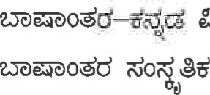
9.0.0. dËéòå.
10.de37«o— Ëdd 0.0. dËéJå.

Il semester
Appendix-X
COURSE 1 - CONSTITUTIONAL LAW -11
Objectives:
This course gives the students a picture of Constitutional Parameters regarding the organization, powers and functions of the various organs of the Government. The emphasis is also on the study of the nature of federal structure and its functioning. A critical analysis of the significant judicial decisions is offered to highlight judicial restraint, judicial activism and judicial balancing. Finally, the students should be able to articulate their independent views over contemporary crucial Constitutional issues.
UNIT-I
Federal system: Organization of State.
Relationship between the Centre and the State: Legislative, Financial and Administrative, Cooperative Federalism and recommendation of Commission.
Freedom of Trade and Commerce, Official Language, Local self-government with special emphasis on 73 ^{rd} and 74th Amendment.
Constitutional provision of Jammu and Kashmir (Art. 370).
Special provisions relating to specific states (Articles 37 1 -A to 371 -J)
UNIT-II
Executive: Centre and State; President and Governor; powers and functions.
Parliament and State Legislature: Bicameralism, Composition, powers and function.
Councils of ministers: collective responsibility, Position of Prime Minister and Chief Minister
UNIT-111
Speaker: Parliament and State Legislature, Powers and Functions, Privileges Anti-Defection
Law.
Judiciary: Union and States, appointment, powers, jurisdiction and Transfer ofjudges.
UNIT-IV
Subordinate Judiciary, Administrative Tribunals.
Public Service Commission: services under the center and the state, Constitutional protection to
Civil Servants.
Election Commission: Powers and functions.
State liability for Torts and Contract.
UNIT-V
Emergency: Types, Effects and effects on Fundamental Rights.
Constitutional Interpretation Amendment: Basic structure theory.
Schedules.
Review of working of the Constitution.
Prescribed Book:
l. M. P. Jain - Indian Constitutional Law Vol 1& Il
Reference Books:
l . H. M. Seervai - Constitutional Law of India
- V. N. Shukla - Constitution of India
- T. K Tope - Constitutional Law
- S. Shiva Rao - Framing of Indian Constitution
- Subash .C. Kashyap - Parliamentary Procedure
- Subash. C. Kashyap - Constitution of India
- D.J. De — the Constitution of India, vol.l and Il.
- J.N. Pandey - Constitutional Law of India
- DD. Basu - Constitutional Law of India
COURSE 11:
CONTRACT-II (SPECIAL CONTRACTS)
Objectives:
This course enables the students to better appreciate the law governing special contracts like, indemnity, guarantee, agency, etc. which are more relevant in the contemporary society. Law contained in several legislations apart from the Indian Contract Act is taught in this Course.
Course contents:
UNIT - 1
Contract of Indemnity —Definition, Nature and Scope - Rights of indemnity holder
Commencement of the indemnifier's liability — Contract of Guarantee — Definition, Nature and Scope — Difference between contract of indemnity and Guarantee — Rights of surety — Discharge of Surety — Extent of Surety's liability — Co-surety.
UNIT - 11
Contract of Bailment — Definition — Kinds — Rights and Duties of Bailor and Bailee — Rights of
Finder of goods as Bailee — Contract of pledge — Definition — Comparison with Bailment Rights and duties of Pawnor and Pawnee
UNIT - 111
Agency — Definition — Creation of Agency — Kinds of Agents — Distinction between Agent and
Servant — Rights and Duties of Agent — Relation of Principal with third parties — Delegation Duties and Rights of Agent — Extent of Agents authority — Personal liability of Agent Termination of Agency.
UNIT - IV
Indian ParÍnership Act — Definition — Nature, Mode of determining the existence of Partnership — Relation of Partner to one another — Rights and duties of partner — Relation of partners with third parties — Types of partners — Admission— Retirement , and Expulsion of partners Dissolution of Firm — Registration of Firms.
UNIT -V
Sale of Goods Act — The Contract of sale — Agreement to sell - Conditions and Warranties Passing of property — Transfer of title — Performance of the Contract — Rights of Unpaid Seller Remedies for Breach of Contract.
Prescribed Books:
Singh, Avtar, Law of Contract and Specific Relief, I Ith Edition, (Lucknow: Eastern Book
Company. 20] 3)
Verma J.P (ed.,) Singh and Gupta, The Law of Partnership in India, (New Delhi: Orient Law House, 1999)
Saharay H. K, Indian Partnership and Sale Q/ Goods Act, (Universal, 2000)
Nair, Krishnan, Law of Contract,( New Delhi: Orient Law House, 1999)
Hire Purchase Act
Reference Books:
Pollock and Mulla, Indian Contract and Specific Relief Act, 14th Edition, (New Delhi: Lexis Nexis, 2013)
Anson, William, Law ofContract, 29th Edition, (Oxford University Press, 2010)
Avtar Singh, Principles of the Law of Sale of Goods and Hire Purchase, (Lucknow; Eastern Book House Ltd, 1998)
Sir Frederick Pollock and Mulla, Pollock and Mulla on the Sale of Goods Act, 9th Edition, (Lexis Nexis: 201 4)
J. P. Verma (ed.), Singh and Gupta, The law of partnership in India,(New Delhi: Orient Law House, 1 999)
Appendix-XI
COURSE 111- LABOUR LAW- 1
OBJECTIVES
In this course, the students are to be acquainted with the Industrial relations framework. Further, the importance of the maintenance of industrial peace and efforts to reduce the incidence of strikes and lockouts are to be emphasised. The main objective is to critically examine the provisions in the Trade Unions Act, 1926; the machineries contemplated under the Industrial Disputes Act, 1947 for the prevention and settlement of industrial disputes and other matters. Further, the objectives underlying the Industrial Employment (Standing Orders) Act, 1946 and Disciplinary Enquiry for misconduct are to be studied with a view to acquaint misconduct and the procedure to be followed before imposing punishment for misconduct alleged and established.
Referring wherever necessary to the Constitutional provisions and the ILO Conventions and recommendations will do learning of these legislations. We will be looking at the judicial response, legislative response and probable amendments required to the industrial relations laws to meet the challenges posed by economic liberalisation. In order to understand the abovementioned legislations in their proper perceptive, a brief historical background of these legislations will also be examined.
In this course, students shall also acquaint with legal frame-work relating to social security and welfare. The concept of social security, its importance and also Constitutional basis for the same are introduced. The importance of ensuring health, safety and welfare of the workmen, social assistance and social insurance schemes and the regulation of wages under various legislations are to be emphasised. The objective is also to understand the provisions of the Employees Compensation Act, 1923, the Employees' State Insurance Act, 1 948, the Payment of Wages Act, 1936, the Factories Act, 1948. These legislations are to be studied with a view to acquaint the students regarding various rights and benefits available to the workmen thereunder. Legislations are to be analysed by examining historical background, objectives underlying these legislations, judicial interpretations and effectiveness of these legislations in the changed economic policies.
UNIT-I
Historical aspects - Master and Slave Relationship, Trade Unionism in India and UK Enactment of the Trade Unions Act, 1926- ILO Conventions relating to Trade Unions and relevant Constitutional provisions.
A bird's eye view of the Act — Definitions - Trade Union, Trade Dispute, etc.
Provisions relating to registration, withdrawal and cancellation of registration - Funds of Trade Union, Immunities, problems of Trade Union, Amalgamation of Trade Union -Recognition of Trade Unions - Methods, need and efforts in this regard, Collective Bargaining - Meaning, methods, status of collective bargaining settlements, collective bargaining and liberalisation.
UNIT-II
Historical Background and Introduction to the Industrial Disputes Act, 1947 - Definitions Industry, Workman, Industrial Dispute, Appropriate Government, etc., - Authorities/ Industrial
Dispute resolution machinery - Works Committee, Conciliation and Board of Conciliation Powers and Functions, Court of Inquiry, Grievance Settlement Authority,
Voluntary Arbitration U/S 10-A, Compulsory Adjudication- Government's power of reference U/S- 10 - Critical analysis with reference to decided cases. Compulsory Adjudication Composition, Qualification, Jurisdiction, powers of adjudication authorities, - Award and Settlement - Definition, Period of operation, binding nature and Juridical Review of award.
UNIT- 111
Law relating to regulation of strikes and lockouts- Definition of strikes and lockouts, Analysis with reference to Judicial Interpretations, Regulation U/Ss 22, 23, 10-A(4-A), and 10 (3), Illegal strikes and lockouts, penalties. - Regulation of Job losses- concepts of Lay-off, Retrenchment, Closure and Transfer of undertakings with reference to statutory definition and Judicial Interpretations - Regulation of job losses with reference to the provisions of chapter V A and V B of the ID Act, 1947 - Regulation of managerial prerogatives - ss. 9A, I IA, 33 and 33A of ID Act, 1947 - Certified Standing Orders - Meaning and Procedure for Certification, Certifying officers- Powers and Functions, etc.
UNIT-IV
Concept and Importance of Social Security - Influence of I.L.O. - Constitutional Mandate. The Employees' Compensation Act, 1923 — Definitions - employee, employer, dependent, partial disablement, total disablement, etc. - Employer's liability for compensation —Conditions and Exceptions Procedure for claiming compensation. Computation of Compensation. Commissioner- Jurisdiction, Powers, etc.
The Employees' State Insurance Act, 1948 — Definitions - Employment injury, contribution, dependent, employee, principal employer, etc. - Employees' State Insurance Funds - contribution, Benefits available - Administrative Mechanism - E.S.I Corporation, Standing Committee, Medical Benefits Council - Composition, Powers, Duties - Adjudication of Disputes
- E.S.I Courts. Comparative analysis of the E.S.I. Act, 1948 with the Employees' Compensation Act, 1923
UNIT-V
The Payment of Wages Act, 1936 - Definitions — employed person, factory, industrial and other establishment, wages, etc. - Deductions — Authorities - Inspectors and Payment of Wages Authority.
The Factories Act, 1948 — Definitions - factory, manufacturing process, occupier, worker, hazardous process, etc. - Provisions of the Factories Act relating to health, safety and welfare of workers - Provisions relating to Hazardous process - Provisions relating to working conditions of employment - Working Hours, Weekly leave, Annual leave facility - Provisions relating to regulation of employment of women, children and young persons.
Books Prescribed:
- S.C. Srivastava - Industrial Relations and Labour Laws. Dr. V.G. Goswami - Labour Industrial Laws S.N.Mishra - Labour and Industrial Laws.
- S.C.Srivastava, Treatise on Social Security.
- The Trade Unions Act, 1926
- The Industrial Disputes Act, 1947
- The Industrial Employment (Standing Orders) Act, 1946
- The Employees Compensation Act, 1923
- The Employees' State Insurance Act, 1948
- The Payment of Wages Act, 1936 The Factories Act, 1948 Reference Books:
- O.P. Malhotra - Law of Industrial Disputes.
- G. Ramanujam - Indian Labour Movements.
- PL. Malik - Industrial Law.
- Mamoria and Mamoria - Dynamics of Industrial Relations.
- First National Labour Commission Report, 1969.
Second National Labour Commission Report, 2002.
- International Labour Conventions and Recommendations.
COURSE-IV PROPERTY LAW
Objectives:
The focus of this course in on the study of the concept of 'Property', the 'nature of property rights' and the general principles governing the transfer of property. A detailed study of the substantive law relating to particular transfers, such as sale, mortgage, lease, exchange, gift and actionable claims will also be undertaken. The course also includes an exposure into the concept of trust.
Course contents:
UNIT - 1
General principles of Transfer of Property by act of parties inter- vivos- Concept and meaning of immovable property- Transfer of Immovable Property- Persons C01npetent to transfer Operation of Transfer- Conditions restraining alienation and restrictions repugnant to the interest created- rule against perpetuity and exceptions- Direction for accumulation- Vested and Contingent interest, void conditions, Rule of acceleration, fulfillment of conditions subsequent.
UNIT - 11
Doctrine of election- transfer by ostensible and co-owner- Apportionment- Priority of rightsRent paid to holder under defective title- Improvements made by bona/ìde holder- Doctrine of Lis pendens- Fraudulent transfer and part-performance.
UNIT - 111
Mortgages of Immovable property: Definition- Kinds of mortgages and their features- Rights and liabilities of mortgagor and mortgagee- Priority of securities- Marshalling and contributionCharges.
UNIT - IV
Sale of immovable property: Rights and liabilities of seller and buyer before and after completion of sale- Difference between sale and contract for sale; Leases of immovable property: Definition- Scope- creation of lease- rights and liabilities of lessor and lesseeDetermination and holding over; Exchange: Definition and mode- Actionable Claims; Gifts: Scope- meaning- mode of transfer- universal gifts- onerous gifts.
UNIT- V
Law of Trusts with Fiduciary Relations: Definitions of Trust and its comparison with other relationships like Debt, Ownership, Bailment, Agency and Contract; Kinds of Trusts- Creation of Trust- Appointment of Trustees- Duties and Liabilities of Trustees- Rights and Powers of Trustees- Disabilities of Trustee- Rights and Liabilities of the Beneficiary- Vacating the office of trustee and Extinction of Trusts.
Prescribed Books:
Mulla, Transfèr ofProperty Act,(Delhi: Universal, 1999)
Tandon, M.P., Indian Trust Act, 1882, 21 ^{st} Edition, (Allahabad Law Agency, 2012)
Reference Books:
Subbarao, Transfer ofProperty,(Madras: Subbiah Chetty, 1994)
Shukla, S.N, Transfer ofProperty Act, 28th Edition, (Jain Book Agency, 2014 )
Tripathi, G.P., The Transfer ofProperty Act, 18th Edition, (Jain Book Agency, 2014)

COURSE-V: FAMILY LAW -11: MOHAMMEDAN LAW AND
INDIAN SUCCESSION ACT
Objectives:
The knowledge of family laws is important for lawyers. This course is designed to endow the students with knowledge of both the codified and uncodified portions of Mohammedan Law. The course concerns itself with the sources, schools, institutions, succession, maintenance, menace of dowry, etc. In addition the students have to familiarize themselves with the provisions of the Indian Succession Acts
Course contents:
UNIT-I
Development of Islamic Law: Advent of Islam & development of Muslim Law, Schools of
Islamic Law, Whos is a Mohammaden; Conversion and its consequences on family: Marriage, Guardianship, Succession; Child and Family: the Shariat Act, 1937; Sources of Islamic Law; Concept of Marriage: Definition, object, nature, essential requirements of a Muslim marriage, classification of marriage - Legal effects of valid, void and irregular marriage - Muta marriage; Customary practices and State regulation: Polygamy; Child marriage; .0ption of Puberty; Dower; Kinds of Dower: Dower when confirmed; Widow's Right of Retention
UNIT-II
Parentage Legitimacy, and Acknowledgement of Paternity Custody, Maintenance and education, Guardianship and parental rights. Matrimonial Remedies under Islamic Law and Indian Divorce Act, 1869(Amended Act) — Modes of Talak — Effects of Talak — Iddat - Nullity of marriage - Bar to matrimonial relief; Alimony and Maintenance: Alimony and Maintenance as an independent remedy- A review under Muslim law, Indian Divorce Act, 1 869, provisions under the Criminal Procedure Code, ] 973; Maintenance of divorced Muslim Women under the Muslim Women (Protection ofRights on Divorce) Act, 1986.
UNIT-111
Will-Meaning, Limitations on a Mohammaden in making a will; Difference between will and gift, Will made in death bed or during illness; Gifts(Hiba) : Essentials of Valid Gift; Kinds of Hiba; Revocation of Gifts; Wakf; Essentials of valid Wakf: Mutawalli — Appointment — Powers and Duties of Mutawalli: Law relating Pre-emption; Nature of Right of Pre-emption; Who can Pre-empt; Formalities; When the Right of Pre-emption is lost.
Unit IV
Muslim law of Inheritance- Shia and Sunni schools; Distribution of property under Indian Succession Act of 1925(Of Christians, Parsis)- Domicile- Kinds of Domicile — Modes of acquisition of Domicile; Parsis Intestate succession and Non Parsis Intestate succession, Succession certificate, Probate and letters of administration, Powers and Duties of Executor,
UNIT-V
Wills — Privileged and unprivileged wills - Construction of Wills in brief- Void bequests, void wills, Kinds of Legacies; Specific and Demonstrative Legacy; Ademption Qf Legacies; Protection ofproperty of the deceased; Appointment of Curator — Powers and Duties Family Courts Act, 1984- Constitution, powers, and its functions; Needfor Uniform Civil Code- Article 44 ofIndian Constitution.
Prescribed Books:
Mulla, Principles ofMohammedan Law,(New Delhi: Lexis Nexis, 1906).
Paras Diwan , Law ofIntestate and Testamentary Succession, 4th Edition, (New Delhi: Universal Law Publishing Co. Ltd, 2013)
Reference Books:
B. B. Mitra ,lndian Succession Act, 1925.1 5 ^{th} Edition, (New Delhi: Jain Book Agency, 2013)
A. A. A Fyzee, Outlines ofMohammedan Law, (Oxford University Press, 1974)
Basu, N.D., Law ofSuccession, 5 ^{th} Edition, (Calcutta: Eastern Law House, 1974)
Paras Diwan, Family Law: Law of Marriage and Divorce in India, (New Delhi: Universal Law Publishing Co. Ltd, 201 1)
A. M. Bhattachargee, Muslim Law and the Constitution (Calcutta: Eastern Law House, 1 994)
Tahir Mohamood, The Muslim Law ofIndia, (Law Book Company, 1 980)
Indian Divorce Act, 1 869 — Bare Act
6
03g℃㈜003D
580025
지0舅: 공㉮丁00/0口흐쑈o冒업/봉협冒/2019-20/ 0&℃0毳1L02.2020.
žñd$ðcod
0`03포 2019-20de ïððdð 3dXFd 0室屳寧.?.0. 5듬`F弓a쭈D寧.乙. 협冒d  공d,文冒0蠡od)협龜爻공00협0
1. d3ðd囹O弓@ri업0 (9출뚀e弓협0.3) 0교0齧: 17.022020.
쬬Qt은)0冒0`0`현)봉 쪄0D0수創冒od 교O齧00 n血월) 협)五00菖0003.)i국협 찐뚀0囹「0粼ê?žò<)ddodd 2019-20邕e 너學쬬 3협`F弓0室0호.20. 5협`F弓 0쭈a호.B.).  회弓e丁0@ 법冒冒0苞0學gd법7국 공d冒DOD 0`0`짓)弓龜)Q *0?0彎00 @얺躬또hd. d3ò0dòdddö奩0협`n협ò 쬬田℃0끄003)de)百0협.fÒ출 공d冒 0`0`d)협협`것 d3ðdðôdò3ðd edd 처0최0`囹출 @얺%2.弓e齧0 쬬회0 쑈苗0訇㉮00`혛ò弓10@0쬬퐁 0핗) Ëddd 협0躬齧d업0 2,de百0尸SC蠡002그)췬弓龜式 030회*.)O출齧@q。9처편e공0 0齧0弓d五뚀전) 공d쳠 협i)쪄봉弓출 爻(3030쬬O쬬心0冒처(:-)ð7적0턴b쑈 coodò 쬬0£弓d do. 125/- 7협0 cadò©d. sdOod 서訇e쪄下囹od 603㉡렶) 롭d冒
0춏0`30蠡협`) 쬬㈜ 꾜龜협`) 쬬교0口D0030齧쬬서공 (9협弓齧d 띸d)勳弓龜)a 교dd`允업7교h 0030齧공금@鬱酌듬og 교O공 (38e9쪄됴hd.
(3[18.
山0%?3협d)
e..Ð冒齧: 몬d冒협d몬협0협협o edêžUðíìd.;
髥,
00 며00로㉦et髥d砲협.允협3 003Dh햅0 홈雨『93齧0030
dddfld, 쇼?0岊- 580 025
0 회@03)협) .
- s협百00.30F弓Ùsr\업0, 듬교흐 \ÒO법@7<업五0뇨800출, 공꾜꾜O, 쑈蜀팀9.
- 면협꾜03.)Fdùsr\업0, 롭00弓弓弓d`) 봉고五O, 쑈00멒.
20
- (5협五0수F弓98r\업0, \꼬)서2,3듬d) (코0뇨弓d), 롭고꾜a, 쑈?0嘗.
- 협㈀꾜酌e勺꾜Ori업0, 몽고꾜0, 쇼2.0엽.
- 테l.)협-콩SO弓23弓d), \죠0쬬0, 쑈乙岊.
00
- **0030 원호


:
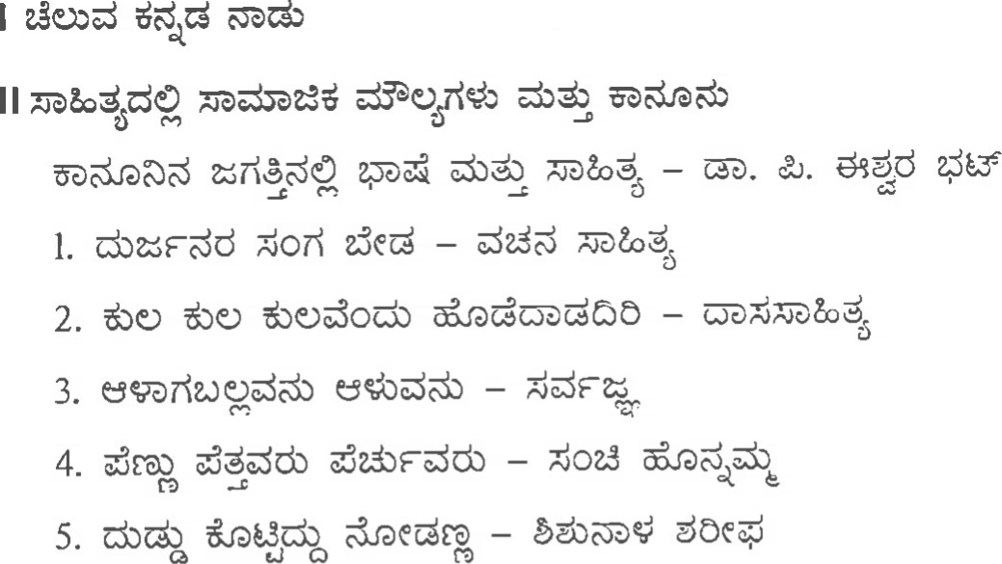5.一5
6. d)一eotîCdod)dd
8 · 0 nod d ?一0
- da.fòddod)一· ddk)0Cïò.、
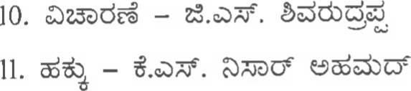
- 023ðdÉ一...z
·
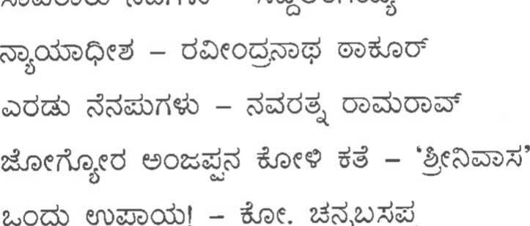
12. 73ð0öðdò O一ždöododù
14.
!
du
13 ·
15.
16. uo
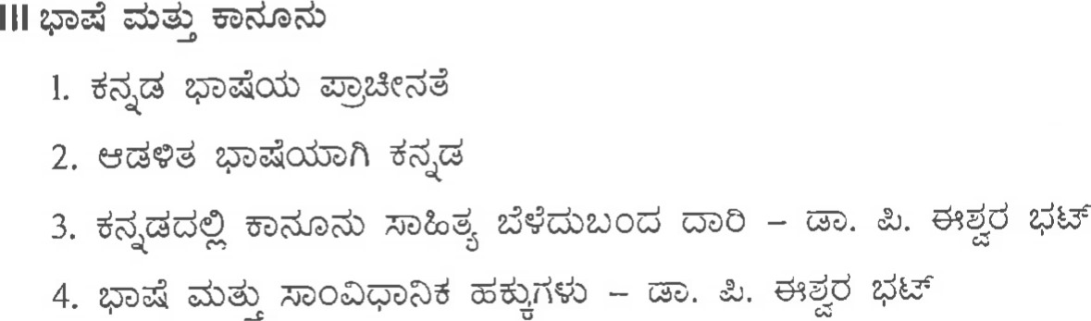

l. e)一dd
- ËÖðdò
- B3ð0d Öðdò
4 · god.)dg
5. 007\dÉ/O?-.Píi 
6 · e-ÐQûd 7.
8 ·

10.
Il.
V dCë$
l. nd OXdå
2. déd

4. epanoCd
e.Ðtuo<

l. Oddo dd7f%t
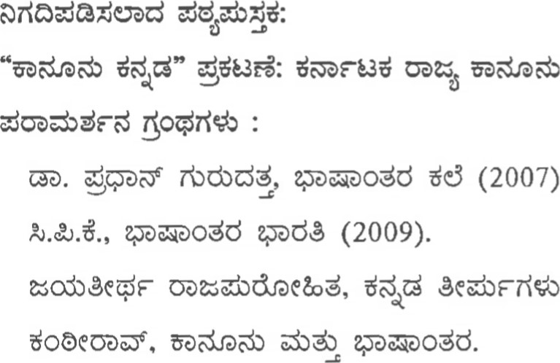
adOãì00±, (2020)
(2007).
(1977).
ËOÒk^{O} öðö^{S}, epdêeodö õð0dò ddê (1985). Ëdad (2018).
ta. doguòuod), Odd0ò ddåÊC.
25 do.òe. Ëdd dog.
Sdnd, 3ðdJîd.) ddåîC.
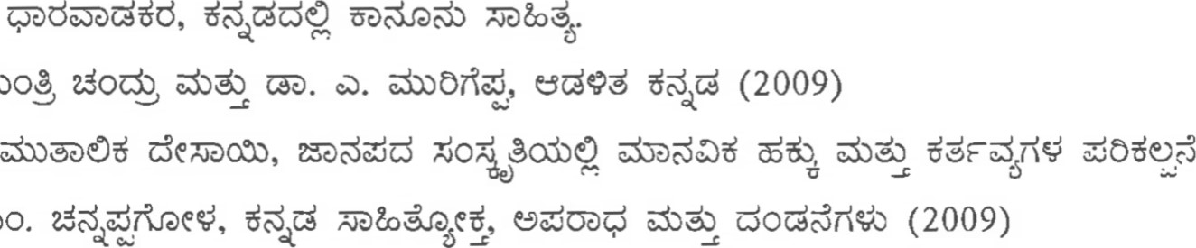
öð.Ob.
06.
00.
óoa)óoê Coct dneê (2017).



t.a/t.u.a/t.no.,ou^{s} au^{s} .t. "Cdd Cc)"
aao±:
SdËdòdö es^{B} dâždòd ËòO©ù.
ndesD: l.ËõðnOod) t.ú.aã. (odòò.d.) Z2$odè 16.07.2018.
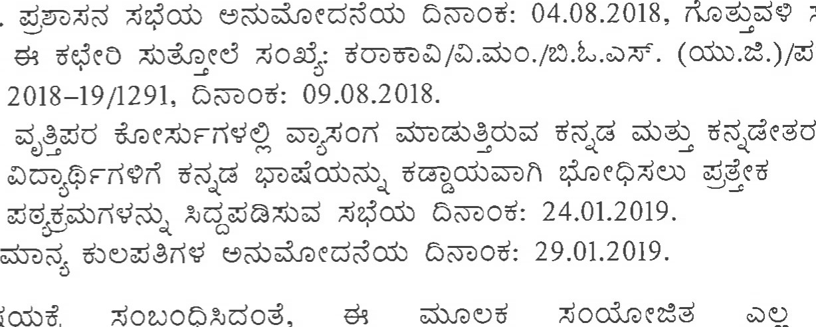
2. Sod: 09
(odòò.æ.)/SdËdò/
4.
SocoQždod,
3.
5.
 ndJðd.)
ê?oogažòdddodd, asocnood)d
eaod.)ð 2018—19dk⁰ Æðöaod c.o/eð.eð.cò/cð.ûo.,au^{s}au^{s} .t.õðfl-î 3dadFd
es^{B} dâžVðñd.  odea) 3d Éòd
d.òõð0cnoodò 39ždož "Cd d CO"
Cdenhd Sodo  2018-19de 2de
d.Mò0Ë
"Cd d SC"  Appendix-VIII—A oflêžc-nñd.
ed ood | òËËOri  êež©òhd. |  | Cod)
end.
 (S?.pd) n,

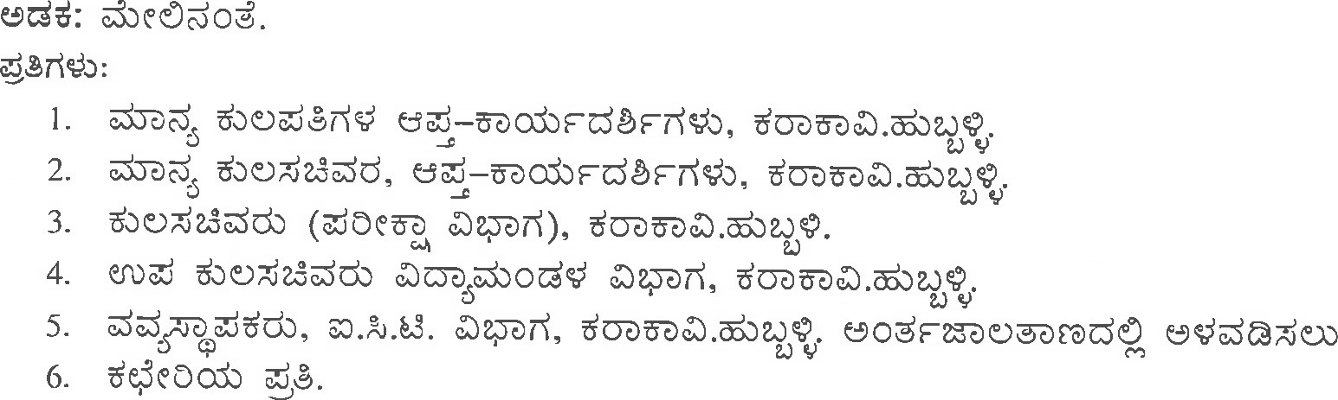
Appendix- Vill-A
deCd  d¿.3ž0ìd 2018-19.
KANNADA KALI
ndcd,'fgt:
cpdodò ddddò dê ddaodò Cd7\ê7dÇö d3ðdùêdòd  da¥öðñd. dod öðœfleod ddòö 
Ddòd
Cd d eCóddFòñdSdòod, €.öð.n.aodò dòõðOcnoodò7^{R}l€åö Ëdd Sd)dedOod Cd ddòdö "±dd SC" óžÊdd) aflodažo-ðñd.
dœd  eÇsoódËodù dCžöðñdòd  Ëeddö wð. öor\dESd.) eddù doddòOod yd*dOod
ËJòCQd. Ëdd  egos  Ëöod.)0ò, d030enSOò sddÖ s dòoog adob Ëœdö õðddd.ýòdd 
Sodddddò  ddõ5òrOd oeèobÖ ^{c}ad) dC©Eöðñd.
Part I : Structure (Ëdd Zod?£dodòd)
1 (Unit 1): Lesson 1 to Lesson 5:
2(Unit 2): Lesson 6 to Lesson 10:
3(Unit 3): Lesson 11 to Lesson 15:
4(Unit 4): Lesson 16 to Lesson 20:
5(Unit 5): Part Il : Kannada Script (destd de.)odùòd 
€¿pdO riòòodòd) d.noOd)
öofideddù (SS d OdOÖðOOdò,dOå,
Kannada Kali (A Language Text Book for the Non-Kannada Professional Degree courses by Lingadevaru Halemane)
Published by Publication Division, Prasaranga Kannada University, Hampi, Vidyaranya 583276 Published year 2002

Ill semester
COURSE-I: JURISPRUDENCE
Objectives:
Any academic discipline, worthy of the name, must develop in the student the capacity for critical thought. Legal education needs to teach both law and its context- social, political and theoretical.
At the heart of legal enterprise is the concept of law. Without deep understanding of this concept neither legal practice nor legal education can be a purposive activity. This course in Jurisprudence is designed, primarily, to induct students into a realm of questions concerning nature of law. Therefore, the first part of the course is concerned with important questions like, what is law, what are the purposes of law? , the relationship between law and justice and the like. The second part is concerned with the important sources of law. The emphasis is on important issues concerning law with reference to ancient and modern Indian Legal Thought.
One important branch of Jurisprudence consists in analysis of legal concepts. The law of contract and tort is concerned with different rights which one person may have against another. Jurisprudence, on the other hand, studies the meaning of the term "rights" in the abstract and seeks to distinguish various kinds of rights which are in theory possible under a legal system. Similarly, it investigates other legal concepts and tries to build up a general and more comprehensive picture of each concept as a whole. This course is designed primarily on English model but native India Orientation is given wherever possible.
Course contents:

Meaning and nature of 'Jurisprudence' Purpose and value of Jurisprudence -Schools of Jurisprudence: Natural law, Imperative Theory, Legal Realism, Historical School, Sociological School.
UNIT-II
Functions and purpose of law, questions of law, fact and discretion - Justice and its kinds - Civil and Criminal Administration of Justice - Theories of Punishment and Secondary functions of the Court.
UNIT - Ill
Sources of Law: Legislation, Precedent and Custom - A Comparative study
UNIT - IV
Legal Concepts: Right and Duty, Kinds, Meaning of Right in its wider sense; Possession: Idea of Ownership, kinds of Ownership, Difference between Possession and Ownership; Nature of Personality, Status ofthe Unborn, Minor, Lunatic, Drunken and Dead Persons.

Liability: Conditions for imposing liability - Wrongful act: Damnum Sine Injuria, causation, mens rea, intention, malice, negligence and recklessness, strict liability, vicarious liability, obligation. Substantive Law and Procedural Law.
Prescribed Books:
Fitzgerald, Salmond on Jurisprudence, (Bombay: Tripathi, 1999).
Dias, R.W.M,Jurisprudence, (Delhi: Aditya Books, 1994)
Reference Books:
W. Friedman ,Legal Theory, (New Delhi: Universal, 1999)
V. D. Mahajan, Jurisprudence and Legal Theory, (Lucknow; Eastern, 1996 Reprint)
Paton ,G.w., Jurisprudence, Oxford, 1972)
Bodenheimer ,Edgar, Jurisprudence, (Harvard University Press, 1974)(Revised Edition)

SDdned
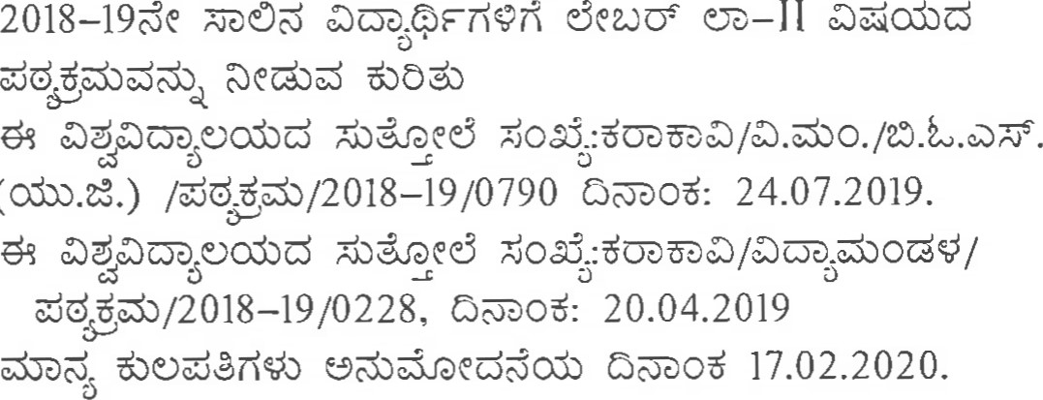
0<00:
(Odòò.t'o.)
Odea):l.
- ·
- ·
d OXodòË ZoooQždož,
ê?odòdažùdddodd, 2016一亅7 , 2017一18 2018一19
2dÖ」dog一Ⅱ d
 |  |  |  | 
 | 2016一17 | 5 | t.à/¿.ù.t.cò/t.no.,ac-feò&.t. | žOòU-oöS | 一Ⅱ
02 | 2017一一18 | 5 | Fd t.à/¿ð.t.à/œ.no.,ausaus.t | 8coe  |  CD—II
03 | 2018一19 |  |  |  | 一Ⅱ
刂4 | 2018一19 | 3 | F e.òe.5aeÉ.cÙ. | 30?  |  UÈ—II
Oeêodöðñ d) deu.)Ö£ U'ð— Ⅱ〕、
or\êX.)Eòhd. sdood  33F 
cnO ©dOò

end
0 do
e..ÐdC: 6- Ⅱ

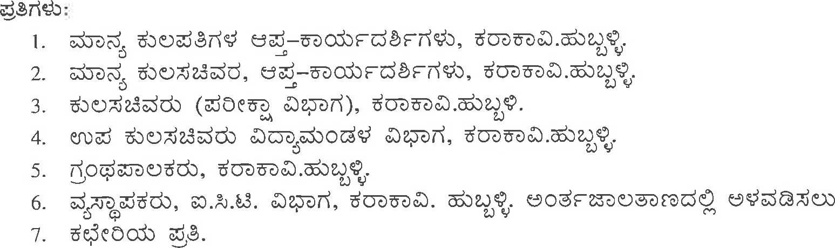

Labour Law- Il
Objectives
In this course, students are to be acquainted with legal frame-work relating to social security and welfare. It is necessary to know the concept of social security, its ilnportance and also Constitutional basis for the same. The importance of ensuring health, safety and welfare of the workmen and social assistance and social insurance schemes under various legislations are to be emphasised. The main theme underlying the programme is to critically examine provisions of the Factories Act, 1948, the Child Labour (Prohibition and Regulation) Act, 1986, the Contract Labour (Regulation &AboIition) Act 1970, the Minimum Wages Act, 1948, the payment of Bonus Act, 1965, the Payment of Gratuity Act, 1972, the Employees' State Insurance Act, 1948, the Employees' Provident Fund (Family Pension Fund and Deposit Linked Insurance Fund) Act, 1 952, the Maternity Benefit Act, 1961, the Unorganised Sector Workers' Social Security Act, 2008, These legislations are to be studied with a view to acquaint the students regarding various rights and benefits available to the workmen thereunder. These legislations are to be analysed by examining historical background, objectives underlying these legislations, judicial interpretations and effectiveness of these legislations in the changing times.
Unit-I Constitutional Dimensions of Industrial Relations and Labour
Constitution and Labour welfare - The Bonded Labour System Abolition Act, ] 976 — The Equal Remuneration Act, 1976 — the Inter-State Migration of Workers Act, 1979 — the Sexual Harassment of Women at Workplace (Prevention, Prohibition and Redressal) Act, 2013.
Unit Il - Wages, Bonus and Gratuity
Concept of Wages — Theories of wages and Kinds of wages.The Minimum Wages Act, 1948 Definitions - appropriate government, employer, employee, Scheduled employment, etc. Fixation of Minimum rates of wages — Methods - Regulation of working conditions - Payment of Wages, Working Hours, etc.
Bonus - Context —a claimfor share in profits even after payment of wages according contract of employment? Is it a breach of contract or an implied term of the contract? — concepts of bonus and right to share in profits - The payment of Bonus Act, 1965 — definitions — provisions relating to payinent of bonus —judicial interpretations and constitutionality of the provision relating to Govt's power to exempt.
Gratuity - Context — reward for long drawn loyal service -employers' liability or good gesture? Historical developments.The payment of Gratuity Act, 1972 definitions judicial interpretation and parliamentary amendment of the definition of employee. — payment of gratuity determ ination of the amount of gratuity — authorities.
Unit Ill — Protection of Child Labour and contract labour
Child labour — practice and reasons for child labour competing views on necessity and feasibility of abolition of child labour — Human rights perspective and constitutional provisions for the protection of child the Child Labour (Prohibition and Regulation) Act, 1986 definitions — provisions relating to prohibition of child labour in certain establishinents and processes regulation of conditions of work penalties — judicial interpretations. AmendiTlents made through The Child Labour (Prohibition and Regulation) Amendment Act, 2016 and Criticisms.
Abolition and regularisation of contract labour, regulation of contract labour under the Contract Labour (Regulation &Abolition) Act 1970 — judicial decisions relating absorption of sham practice of contract labour — evaluation ofthe working of the Act in the present days.
Unit-IV Social Security
The Employees' Provident Fund (Family Pension Fund and Deposit Linked Insurance Fund) Act, 1952 — Definitions- contribution,employee, employer, factory, fund, etc. - Provident Fund Scheme, Family Pension Scheme, Employees' Deposit Linked Insurance Scheme — Scope, Contributions - Benefits - Authorities under the Act — Powers.Latest judicial pronouncements.
The Maternity Benefit Act, 1961- Object and Scope of the Act, Definitions appropriate government, employer, establishment, factory, maternity benefit,wages,etc. - Benefits under the Act - Inspectors.
Unit —V Protection of unorganised labour
Features and scheme of protection of workers in unorganised sector under the Unorganised Workers' Social Security Act, 2008
Necessity of protection of unorganised labour in shops and establishments by regulating their working conditions - the Karnataka Shops and Commercial Establishments Act, 1961 application of the Act, Hours of work, annual leave with wages - wages and compensation employment of children and women — authorities and penalties.
Globalisation, Privatisation and Open Economy- Effects of Globalisation on Industry and Labour Constitutional Mandate of Welfare State and effectiveness of Social Security and Social welfare legislations in India under new economic policy - Review of laws to meet new challenges - Legislative and Judicial response/trend towards application of Labour lawsEmergence of laws relating SEZs, etc.
Prescribed books
- K.M. Pillai - Labour and Industrial Laws. S.N.Mishra - Labour and Industrial Laws.
- S.C.Srivastava, Treatise on Social Security.
- Sairam Bhat, Privatisation and Globalisation: The Challenging Legal Paradigm
- Jwitesh Kumar Singh, Labour Economics: Principles, Problems and Practices
- Joanne Conagham, Labour Law in an Era of globalisation, Transformative Practices and possibilities
C. S. Venkata Ratnam, Globalisation and Labour-Management Relations, Dynamics of Change
Reference books:
- Dr.V.G.Goswami - Labour Industrial Laws. O.P. Malhotra - The Law of Industrial Dispute. N.G.Goswami - Labour and Industrial Laws.
- Khan and Khan - Labour Law.
- Bhargava, V.B. — Industrial and Labour Laws.
Pai, G.B.-Labour Law in India.
- Srivatava, S.C. - Industrial Relations and Labour Laws.
- Singh, S.N. - Law and Social change: Essays on Labour Laws and Welfare research methodology and environmental protection.
- Report of the First National Commission on Labour (1966-69).
Report of the National Commission on Labour, Government of India, 2002. ILO Recommendations.


KARNATAKA STATE LAW UNIVERSITY
Navanagar, Hubballi-580025
Accredited with 'A' Grade by NAAC
Phone: 0836-2222472 Website :www.ks]u.ac.in
Fax : 0836-2223392 Email : kslu.affiliation2009@gmail.com

No.KSLU/Academic/BOSUG/Taxation/2017-18/ 0606 Date: 07.07.2017.
Notification
Sub: Change of Syllabus of "Taxation" for 3years LL.B. and 5years B.A.,LL.B. 5years B.B.A., and 5years B.Com., LL.B. Courses.
Ref: l.. Resolution of B.O.S. (U.G.) meeting held on 29.06.2017.
- Approval of Syndicate Meeting held on 01.07.2017, Table Agenda No: 03.
- Approval of Hon'ble Vice chancellor, dtd: 07.07.2017.
With reference to the above, the Principals of all Law Colleges of Karnataka State Law
University are hereby notified that the syllabus of "Taxation" course for 3years LL.B. (3 ^{rd} Semester), 5years B.A., LL.B. (7 ^{th} semester), 5years B.B.A.,LL.B. (7th semester), and 5years
B.Com., LL.B. (7 ^{th} semester) programmes is changed as appended to this notification in Annexure-I with effect from the academic year 2017-18. Further, it is notified that the syllabus of "Taxation" course for 3years LL.B. (6th Semester), 5years B.A., LL.B. (1 0th semester), 5years
B.B.A., LL.B. (1 0th semester) programmes (old 3 and 5 year LL.B. degree programmes) is also changed as appended in Annexure-I with effect from the academic year 2017-18. The same may be brought to the notice of all the teachers and students.
Singed.

REGISTRAR O/c)
Encls: Annexure-I Syllabus of the course on "Taxation."
To
The Principals/ Directors of all the Law Colleges/Schools affiliated to Karnataka State Law University, Hubballi.
Copy to:
l. P.S. to the Vice-Chancellor. Karnataka State Law University, Hubballi.
- P.S. to the Registrar, Karnataka State Law University, Hubballi.
- P.S.to the Registrar (Evaluation) Karnataka State Law University, Hubba]li.
- D.R./A.R. Academic Section, Karnataka State Law University, Hubballi.
- ICT Incharge for uploading in the K SLU website.
- Office copy.
Annexure-I
111 (3Yr) /VII (5Yr)-SEMESTER - COURSE-111: TAXATION
OBJECTIVES
Legal regime of Tax encompasses the policies, Laws and rules for Taxation process. Income Tax Law is concerned with tax imposed on various sources of income. With regard to indirect tax latest in the pipeline of fiscal policy is introduction of uniform Goods and Service Tax (G S T) regime by July l, 2017. Tax Policy is related to duties on imports from foreign countries and all compulsory levies imposed by the Government on Individuals firms, limited companies, Govt. organizations, Local Authorities and others for the benefit of the State. The object here is imparting conceptual understanding to the students of the provisions of both direct and indirect tax laws. The students of law are required to know the impact of taxation on business transactions.
COURSE
CONTENTS UNIT-I
General
Concept of Tax- Nature and characteristics of different types of taxes- Direct and Indirect taxes-Distinction between tax and fees, tax and Cess-Tax evasion, Tax planning and Tax avoidance- Retrospective Taxation-Federal Base of Taxing Power -Power of Taxation under the Constitution, Immunity of State agencies/lnstrumentalities- Fundamental Rights and the power of Taxation- Commerce Clause, Inter-State Commerce and Taxation, Scope of Taxing powers of Parliament. Delegation of taxing power to State Legislatures and Local bodies
UNIT-11: Direct Tax Regime
The Income Tax Act 1961: Basis of taxation of Income —Basic concepts, Person, Residential Status and incidence of tax, Income from Salaries-Income from House Property-Income from Business or profession and vocation-Capital gains, Income from other sources-Deemed assessee, Set off and carry forward Loss; Incomes exempt from tax, permissible deductions & Chapter VIA deductions, Assessment, Kinds of assessment, Income tax authoritiesAppointment-powers and functions. Provisions relating to collection and recovery of taxfiling of returns, electronic filing, l.T.Portal working and Refund of tax, appeal and revision provisions, offences and penalties.
UNIT-HI: Indirect Tax Regime
Concept of Goods and Service Tax (GST)-The Constitution (122 ^{nd} Alnendlnent) Act 2017. The Central Goods and Services Tax Act, 2017- Dual GST model taxation- CJST Council — Central GST (CGST); GST levy on transactions-sale, transfer, Purchase, barter, lease, or import of goods and/or services. IGST / SGST /UTGST/ compensation Law to State Governments GSTN-Goods and Services Tax Network Portal; Tax Invoice, GST on Imports & Exports, benefits of GST to trade, industry, e-commerce & Service Sector and the consumers at large, Impact of GST on GDP of India and Inflation.
UNIT-IV: Indirect Tax Regime:
IGST- Integrated CJST (IGST) levied by the Central Government. I liter-state transactions and imported goods or services- State GST (SGST) ; The State Goods & Service tax Law, Power of Central government to levy tax on interstate taxable supply,
Impact of GST on State revenue; Indemnifying State Revenue Loss; UTGST-Union Territory Goods and Service Tax Law-GST Exemption on the sale and purchase of securities, Securities Transaction Tax (STT)
UNIT-V: Custom Law
Legislative Background of the levy-ports-Warehouses-Nature and restrictions on exports and imports-Levy, exemption and collection of customs, duties and overview of law and procedure-Clearance of goods from the port, including baggage-Goods imported or exported by post and stores and goods in transit-Duty drawbacks provisions, AuthoritiesPowers and functions and SEZ Units.
Prescribed Books ^{t}
Sumit Dutt Majumder, GST in India, 2 ^{nd} edn., (New Delhi: Centax Publications Pvt. Ltd., 2016/2017.
Taxmann's Income Tax Act, 60th edn., (New Delhi: Taxmann Publications Pvt. Ltd., 201 6/2017
R. K. Jha and P.K.Singh, A Bird's Eye view of GST, I ^{st} edn., (Hyderabad: Asia Law House,
Reference Books/websites/Portals
Arvind P Datar. Kanga and Pa]khivala's The Law and Practice of Income Tax. 10th edn. (Nagpur: LexisNexis. 2014).
Sampath lyengar's. Law of Income Tax I I ^{th} edn., (New Delhi: Bharat Law House Pvt. Ltd.,
Income-Tax Act, 1961 and Income-Tax Rules, 1962 as amended by latest Finance Act,2016-17

Appendix- II
CRIMINAL LAW -II
BHARATIYA NAGARIK SURAKSHA SANHITA, 2023
JUVENILE JUSTICE (CARE AND PROTECTION OF CHILDREN) ACT, 2015
& THE PROBATION OF OFFENDERS ACT, 1958
OBJECTIVES:
Transition from Code of Criminal Procedure to Bharatiya Nagarik Suraksha Sanhita, 2023 (BNSS 2023) is the result of shifted attention from penalty to nyaya. The primary objective of this course is to familiarize the students with the basic procedure relating to investigation and trial of offences along with the procedure of rendering judgments. The students are also expected to appreciate role of technology in different criminal provisions and the importance of time bound remedies.
Unit I: Introduction
Meaning and importance of criminal procedure; Background and salient features of Bharatiya Nagarik Suraksha Sanhita including its Constitutional dimensions;Definitions and classification of offences- Bail, Bail bond, Bond, Audio-Video Electronic Means, Victim, Investigation; Replaced provisions relating to Organisation, Functions, Duties and Powers of Courts, prosecution and Police under BNSS.
Initiation of criminal case- First Information Report, Zero FIR, Investigation powers, Preliminary Inquiry, Complaint; Arrest-Concept, procedure and safeguards, Proclamation, Information regarding arrested persons, Handcuffing.
Unit II: Pre -Trial Process and Commencement of Proceedings
1. Magisterial power to take cognizance and timelines to complete the proceedings;
2. Dismissal of complaints;
3. Commencement of proceedings;
4. Framing of Charge and joinder of charges;
5. Process to compel appearance and production of things- Use of electronic means, securing presence of successor;
6. Preliminary pleas under the Sanhita- Plea of guilt, limitation for taking cognizance of offences;
7. Provisions as to Bail and Bonds.

1
Unit III – Trial Process
1. Trial before Court of Sessions;
2. Trial of Warrant and Summons cases by Magistrates;
3. Summary Trials – Significance;
4. Evidence and General Provisions as to inquiries and trials;
5. Compounding of offences and Plea bargaining;
6. Concurrent and consecutive running of Sentences;
7. Appeals, Revision and Reference;
8. Security for keeping peace and good behavior;
9. Maintenance – Alteration and Enforcement.

Unit IV: Miscellaneous Procedure
1. Judgment;
2. Transfer of cases;
3. Execution, suspension, remission and commutation of Sentences and Mercy petitions;
4. Disposal of property- photography, videography and time bound release;
5. Preventive action of PSolice;
6. Irregular proceedings;
7. Protection of Victims- Compensation and Treatment.

Unit V: Juvenile Justice and Probation of Offenders
1. The Juvenile Justice (Care and Protection of Children) Act, 2015-Salient features, the Juvenile Justice Board –Composition, Powers and Functions; Procedure relating to Children in conflict with Law, Children in need of Care and Protection and their rehabilitation, Child Welfare Committee.

2. The Probation of Offenders Act, 1958-Salient features, Power of Court to release certain offenders on probation/ good conduct; Power of Courts to require released offenders to pay compensation and cost; Appeal and Revision.

2
Prescribed Books:
1. Ratanlal and Dhirajlal's, Bharatiya Nagarik Suraksha Sanhita, Lexis Nexis,(the latest edition comprising the BNSS, 2023)
2. K.N. Chandrashekaran Pillai (Revd.), R V Kelkar’s Criminal Procedure (Recent Edition), Eastern Book Publication.

Reference Books
1. Bare Act –Bharatiya Nagarik Suraksha Sanhita, 2023.
2. K.N. Chandrashekaran Pillai (Revd.), R V Kelkar’s Lectures on Criminal Procedure (Recent Edition), Eastern Book Publication.
3. Bare Acts -The Juvenile Justice (Care and Protection) Act, 2015 &The Probation of Offenders Act, 1958.
4. M.P. Tandon, Criminal Procedure Code, Central Law Agency (latest edition)
5. S C Sarkar, PC Sarkar and Sudipto Sarkar, Sarkar: The Code of Criminal Procedure (Recent Edition), LexisNexis.
6. Ratanlal and Dhirajlal's, The Code of Criminal Procedure, 1973, Lexis Nexis,(Recent Edition).
7. J.K.Verma, Bharatiya Nagarik Suraksha Sanhita, 2023 (Criminal Procedure): A Commentary, Eastern Book Publication.

Important Note
• The teachers and students have to refer the provisions as amended upto date referring the latest editions of books on the subject.


Soa3 :ËöðîO/OC3ð óod€/žooaøeœd/2019—20/0992 OFEOË: 23.08.2019

(Administrative Law) 5 d3òâdòd odea): l. 040ü5ðJoo.±d god: ËöðnO/åX/OCöðdòod ^{e}è/ž003.neœd
/œ.L.aã.œD.œ/ 2015-16/0651, 17.06.2015
2. óodêrì€ edòdJîk⁰ ddod) OöÒOË: 23.08.2019.
0<odùË, ZouoQždož, 
adOöðoodòË, ZOO.i.neœdflSòOd ao ê?dòdaòddodd,
OZOc3ðJoobd Cd dêËodòò ^{c}ad)$dOod
(Administrative Law) O<odòdd) 5 dugr\s^{B}ö Oofiaž dd or\êžond.
ed Ood  sod5ð Cod) dd0ò  êežöîñd.
end aož)Cddo
d,

eddfl€o: ±ee-3 deed  07<êž£ìñd.
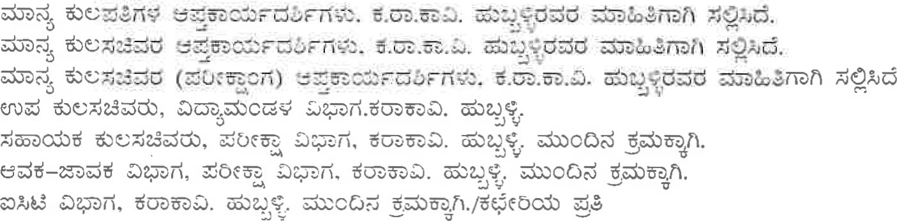
1.
2.
3. 4.
5.
6.
7-
COURSE V: ADMINISTRATIVE LAW
Obj ective.
Administrative law is basically concerned with triple function of administrative authorities, their constitutional limits and statutory limitations, the procedure to be followed in the exercise of their functions and the necessity to study in depth relevant remedies. Constitutional or otherwise in case of administrative arrogance and consequent abuse of power.

Course content
Unit I — Definition of Administrative Law — Nature and scope — The impact and implications of the Doctrine of Separation and the Rule of Law on Administrative
Law, Classification of Administrative Action — the necessity
Unit Il — Legislative Power of Administration — Doctrine of Vice of excessive Delegation - Judicial and Parliamentary control over delegative legislation
Advantages and disadvantages of delegated legislation — Exclusion of Judicial Review of Delegated Legislation, Administrative directions.
Unit 111 Judicial power of Administration — Tests to determinse when an administrative authority required to act judicially - Doctrine of Bias — Doctrine of Audi Altrem Partem — Reasoned decision — Exceptions to Natural Justice — Effect of non-compliance with rules of Natural Justice — grounds on which decision of quasi-judicial authority can be flaged before Supreme Court
Unit IV - Administrative Discretion - Grant and exercise of discretion - Judicial review of Administrative Discretion, Control of Administrative Action Judicial
Control — Public Law and Private Law Remedies — distinction
Writs — Theory, Practice and Procedure — ouster clause
Liabilities of the state in the province of Contract and Tort — Constitutional Tort Doctrine of Promissory Estoppels — Doctrine of legitimate expectation — Doctrine of proportionality
Unit V - Corporate and Public Undertakings — Control of statutory corporations and public undertakings Administrative deviance — Corruption and mal administration — Control mechanism
Ombudsman in India (Lokpal and Lokayukta) — Central Vigilance Commission — Parliamentary Committees — Commission of Enquiry

Prescribed Books
M.P.Jain & S.N.Jain, Principles of Administrative law, latest edition Reference Books
Wade, Administrative Law, latest edition
S.P.Sathe, Administrative Law, latest edition
I.P.Massey, Administrative Law, latest edition

IV semester
COURSE-I: PUBLIC INTERNATIONAL LAW
Objectives:
The course includes the study of general principles of international law including law of peace. Third world concerns in respect of security and development and the role of U.N. and International Agencies in structuring solutions in the context of changing balance of power are also to be appreciated.
Course contents:
UNIT-I
Nature, definition, origin and basis of International Law; Sources of International Law; Relationship between Municipal and International Law; Subjects of International Law.
UNIT- 11
States as subjects of International Law: States in general; Recognition; State territorial sovereignty.
UNIT -111
State Jurisdiction: Law of the sea; State Responsibility; Succession to rights and obligations.
UNIT - IV
State and Individual - Extradition, Asylum and Nationality; the agents of international business; diplomatic envoys, consuls and other representatives; the law and practice as to treaties.

The United Nations Organisation Principal organs and their functions; World Trade Organisation- Main features; International Labour Organisation.
Prescribed Books:
Starke, J.G, An Introduction to International Law (Oxford University Press, 2013).
Sands Philippe and Pierre Klein, Bowett 's Law ofInternational Institutions, 6¹¹⁷ Edition, (Sweet &
Maxwell, 2009)
Reference Books:
Clapham, Andrew, Brierley's Law of Nations: An Introduction to the Role of International in Internalional Relations, 7 ^{th} Edition,(Oxford: 2012)
Harris ,D.H, Cases and Materials on International Law, 7th Edition, (Sweet and Maxwell, 201 0) Oppenheim , International Law, 9th Edition, (Oxford, 2008)
Kapoor, S.K, International Law, Human Rights (Central Law Agency, 2009).
Das, Bhagirathlal, An Introduction to World Trade Organization Agreements (Zed Books, 1998).

OPTIONAL-I
HUMAN RIGHTS LAW AND PRACTICE
Objectives:
The objectives of the course are to prepare for responsible citizenship with awareness of the relationship between Human Rights, democracy and development; to foster respect for international obligations for peace and development; to impart education on national and international regime of Human Rights; to sensitize students to human suffering and promotion of human life with dignity; to develop skills on human rights advocacy and to appreciate the relationship between rights and duties and to foster respect for tolerance and compassion for all living creatures. Course contents:
UNIT 1
Jurisprudence of Human Rights; Nature, definition, origin and theories of human rights.
UNIT - 11
Universal protection of human rights- United Nations and Human Rights- Universal Declaration of Human Rights, 1948; International Covenant on Civil and Political Rights, 1966; International Covenant Economic, Social and Cultural Rights, 1966.
UNIT - 111
Regional Protection of Human rights- European system- Inter American System- African Systelïl
UNIT - IV
Protection of Human Rights at national level; Human rights and the Constitution; The Protection of Human rights Act, 1993.
UNIT - V
Human Rights and Vulnerable Groups: Rights of Women, Children, Disabled, Tribals, Aged and Minorities - National and International Legal Developments.
Prescribed Books:
Theodor, Meron, Human Rights and International Law: Legal and Policy Issues, 2 Vols.
Kapoor,S.K., International Law and Human Rights, Central Law Agency, 2014).
Reference Books:
Luis, Henkin, "The Rights of Man Today", University of Miami Inter- American Law Review, vol., I l , spring 1979 (p.229-244)
Singh, Nagendra,Enfòrcement of Human Rights in Peace and War and the future of humanity, (Calcutta: Eastern Law House 1 986) Relevant International Instruments.
United Nations Charter, 1945.
Universal Declaration ofHuman Rights, 1948.
International Convention on the Elimination ofAll Forms ofRacial Discrimination, 1948.
International covenant on civil and Political Rights, 1966.
International covenant on Economic and Cultural Rights, 1966.
Convention on Elimination ofAllforms ofDiscrimination against Women, 1979.
Convention on the Rights of the Child, 1989.
OPTIONAL-I:
INSURANCE LAW
Objectives:
The insurance idea is an old-institution of transactional trade. The main objective of every insurance contract is to give financial security and protection to the insured from any future uncertainties. Hence, insurance is considered as an inevitable component of economic development. Even from olden days merchants who made great adventures, gave money by way of consideration to other persons who made assurance, against loss of their goods, merchandise ships and things adventured. The rates of money consideration were mutually agreed upon. Such an arrangement enabled other merchants more willingly and more freely to embark upon further trading adventures. The operational framework of insurance idea is provided by the general principles of contract. The insurance policy, being a contract, is subject to all the judicial interpretative techniques of rules of interpretation as propounded by the judiciary. Besides, the insurance idea has a compensatory justice component. This course is designed to acquaint the students with the conceptual and operational parameters of insurance law in the light of various legislations regulating insurance sector in India.
Course contents:
UNIT - l
Introduction: Nature — Definition - History of Insurance - History and development of Insurance in India, Contract of Insurance: Classification of contract of Insurance: (Life insurance - General insurance and Re-insurance — A brief overview), Nature of Insurance Contract, Overview of Insurance laws in India: Insurance Act, 1938 - Insurance Regulatory and Development Authority Act, 1999: Its role and functions.
UNIT - Il
Principles of Insurance law: Principles of good faith (Liberrimae fidei) — Non disclosure
Misrepresentation in Insurance Contract, Insurable Interest, Principle of Indemnity — Difference between Indemnity and Guarantee, Principle of Contribution, Principle of Subrogation, Principle of Loss Minimization The risk — Meaning and scope of risk, Causa Proxima Premium: Definition - Method of payment - Days of grace — Forfeiture - Return of premium, Assignment of the subject matter.
UNIT - Ill
Life Insurance: Nature and scope of Life Insurance, Kinds of Life Insurance, The policy and formation of a Life Insurance contract. Event insured against Life Insurance contract, Circumstance affecting the risk, Amount recoverable under the Life Policy - Persons entitled to payment - Settlement of claim and payment of money - Life Insurance Corporation Act, 1956 (overview) - General Insurance Business (Nationalization) Act, 1972 (overview) — Health and Medical Insurance, The Motor Vehicles Act, 1988 Sec. (]40-176) - Nature and scope Absolute or no fault liabilities, Third party or compulsory insurance of motors vehicles - Claims Tribunal — Legal aspects of Motor Insurance.
UNIT - IV
Fire Insurance: Nature and scope of Fire Insurance — Basic Principles — Conditions & Warranties Right & Duties of Parties — Claims — Some Legal Aspects, Introduction to Agriculture Insurance — History of Crop Insurance in India — Crop Insurance Underwriting, Claims, Problems associated with Crop Insurance, Cattle Insurance in India, Micro Insurance, Public Liability Insurance: Public Liability Insurance Act, 1991 (overview) — Clailns, Consumer courts and Insurance Ombudsman.

Marine Insurance: Nature and Scope - Classification of Marine policies - Insurable interest Insurable values - Marine Insurance and policy - Conditions and express Warranties - Voyage Deviation - Perils of sea — Loss - Kinds of Loss - The Marine Insurance Act, 1963 (Sections I to 91).
Prescribed Books:
Murthy K.S.N and K. V. S. Sharma , Modern Law of Insurance in India, (New Delhi:Lexis Nexis,2009)
Srinivasan , M.N., Principles ofInsurance Law, 7th Edition, (Nagpur: Wadhwa and Co., 2004).
Reference Books:
Singh,Avtar, Law ofInsurance, (Jain Book Agency,2004)
Birds, John, Bird's Modern Insurance Law,8th Edition, (London: Sweet & Maxwell, 1997)
W Patterson, Edwen, Cases and Materials on Law of Insurance (New York: Foundation Press, 1955)
Insurance Act, 1938.
The Marine Insurance Act, 1963.
General Insurance (Business) (Nationalization) Act, 1972 The Life Insurance Corporation Act, 1956. Motor Vehicle Act, 1988.

OPTIONAL-11:
BANKING LAW
OBJECTIVES :
A Vitally important economic institution the banking is deeply influenced by socio-political and economic changes. The emerging changes in India, particularly after the initiation of the planning process as an instrument of rapid economic development had molded and the affected the banking structure, policies, patterns and practices. A significant development in the banking system is diversification in banks financing. The Commercial banks entered into the field of wide ranging financial assistance to industry, both large and small scale, requiring the need for social control of the banking system eventually leading to the nationalization of banks.
The conventional banking system, found to be deficient for planned developmental purposes, paved the way for developmental banking. The fag of the last millennium witnesses influx of foreign banking companies into India and a shift in the banking policy as part of the global phenomenon of liberalization. The legal system is adopting itself into the new mores.
This course is designed to acquaint the student with the conceptual and operational parameters of banking law, the judicial interpretation and the new and emerging dimensions of the banking system.
UNIT-I
NATURE AND DEVELOPMENT OF BANKING - History of banking in India and elsewhereindigenous banking-evolution of banking in India — different kinds of banks and their functions.Multi-functional banks- growth and legal issues.
LAW RELATING TO BANKING COMPANIES IN INDIA: Controls by government and its agencies: On management-On accounts and audit-Lending-Credit policy-Reconstruction and reorganization-Suspension and winding up.
UNIT-II
BANKING REGULATION ACT, 1949: Evolution of Central Bank, Characteristics and functions, Economic and social objectives, The Central bank and the State- as banker's bank, The Reserve Bank of India as the Central Bank.
ORGANISATIONAL STRUCTURE - Functions ofthe RBI- Regulation of monitory mechanism of the economy - Credit control - Exchange control-Monopoly of currency issue Bank rate policy formation. Control of RBI over non- banking companies, Financial companies, Non financial companies.
THE DEPOSIT INSURANCE CORPORATION ACT, 1 961 : Objects and reasons- Establishment of Capital of DIC, Registration of banking companies insured banks, liability of DIC to depositors. Relations between insured banks, DIC and Reserve Bank of India.
UNIT-111
RELATIONSHIP OF BANKER AND CUSTOMER: Legal character, Control between banker and customer, Banker's lien, Protection of bankers, Customers - Nature and type of accountsSpecial classes of customers- lunatics, minor, partnership, corporations, local authorities, Right and duties of Banker & customer. Consumer protection-banking as service.
UNIT-IV
LAW RELATING TO NEGOTIABLE INSTRUMENTS, 1 881 ACT (read with the amended act of 2002) Negotiable Instrument — Kinds- Holders and holder in due course — Parties - Negotiable Assignment - Presentment — Endorsement — Liability of parties — Payment in due course Special rules of evidence — material alteration — Noting and protest — Paying banker and collecting banker — Bills in sets — Penal provisions under NI Act- banker's book evidence Act
UNIT-V
LENDING BY BANKS: Good lending principles- Lending to poor masses- Securities for advances- Kinds and their merits and demerits — Repayment of loans: rate of interest, protection against penalty- Default and recovery — debt recovery tribunal.
RECENT TRENDS OF BANKING SYSTEM IN INDIA: New technology, Information technology , Automation and legal aspects, Automatic teller machine and use of internet, Smart card, Use of expert system, Credit cards.
Prescribed Books:
Tannan,M.L., Banking Law and Practice, (Lexis Nexis,2014).
M. S. Parthasarathy (Ed.), Khergamvala, Negotiable Instruments Act (Bombay: N.M. Tripathi Pvt Ltd, 1955)
Justice Bhaghabati Prasad Banerjee, Guide to Securitisation and ReconsÍrztc1ion of Financial Assets and Enforcement ofSecurity Interest Act, 2002.
Reference Books:
Singh, Avtar, Laws ofBanking and Negotiable Instruments, (Eastern Book Co., 2007)
Basu , Saroj Kumar and Alak Ghosh, A Review of Current Banking Theony and Practice, ( Mc Millan, 1974)
Paget, Law of Banking, I D Edition, (UK: Lexis Nexis,2007)
Goyle, L.C., The Law ofBanking and Bankers, (Eastern Law House, 1995)
Relevant provisions of Information Technology Act, 2000

OPTIONAL-11:
RIGHT TO INFORMATION
Objectives:
Free exchange of ideas is a basic pillar of a democratic society. Corruption thrives in sacred places, therefore it is stated that sunlight is the best disinfectant. There should be governance in sunshine. The course is designed to convince the students how the right to information infuses transparency and accountability in governance, preventing abuse of power.
Course contents:
UNIT-I
Historical development of Freedom of Information in Sweden, USA & UK. Right to Infonnation before Right to Information Act, 2005 in India. Significance in democracy; Constitutional basis; Supreme Court on right to information.
UNIT-II
RTI Act- definitions; Right to information and obligations of public authorities.
UNIT-111
Central information commission; State information commission; Powers and functions of infonnation commissions; Appeals and penalties.
UNIT-IV
Other related laws - The Official Secrets Act, 1923; The Public Records Act, 1 993; The Public Records Rules, 1997; The Freedom of Information Act, 2002; The Commission of Inquiry Act, 1952; The Commission of Inquiry (Central) Rules, 1972.
UNIT-V
RTl Judicial response: Supreme Court & High Court decisions on RTI: Best practices - A study of decisions rendered by state commissions and central Commission in the following areas of — Police, Revenue, PWD, Irrigation, Secretariat, BSNL, Posts and Telegraphs, Scheduled Banks, CPWD. Income Tax Department, Central Excise Department, Local Authorities.
Prescribed Books: J.H.Barowalia, Commentary on the right to Infbrmation Act (Universal Law Publications.
Kamath, Nandan, A Guide to Cyber Laws and IT Act, 2000 with Rules and Notifications, 3 ^{rd} Edition(Universal Law Publisher, 2007)
Reference Books:
Dr. Farooq Ahmed, Cyber Law in India, 3 ^{rd} Edition, (New Era Law Publisher, 2008)
Joga Rao, S.V., Law Relating to Right to Information-A Comprehensive and Insightful Commentary with comparative Perspectives, (Jain Book Agency, 2009)
Dr. Madubhushi Sridhar: Right to Information, Law & Practice (latest edition).

CLINICAL COURSE-I
PROFESSIONAL ETHICS AND PROFESSIONAL ACCOUNTING
SYSTEM
Objective:
Professions are noble. The movement of all professions, hitherto, has been from chaos to organization, organization to consolidation and consolidation to autonomy and monopoly. Same is true of the law profession also. The prime reason for conferring autonomy and monopoly by the society on the professionals is the fact that they are a body of learned persons and the interest of society and individuals is safe in their hands. The Bar should set enviable standards of ethics and scrupulously adhere to them as also enforce them. It is too good of the society to trust the learned body of the professionals to regulate themselves and not to empower an outsider to sit in judgment over their activities. The trust reposed by the society in profession is to be zealously guarded. The Bar should live up to the expectations of the society. The society has a right to expect of the professionals such ideal behaviour. The course is designed to imbue students with these high values forming the basis of the profession so that they can live up to those standards in their professional life.
Course contents:
UNIT-I
The legal profession and its responsibilities; The equipment of the lawyer; Conduct in Court; Professional conduct in general; Privileges of a lawyer; Salient features of the Advocates Act, 1961.
UNIT-II
Duty to the Court; Duty to the profession: Duty to the opponent; Duty to the client; Duty to the self; Duty to the public and the State.
UNIT-111
Contempt of Court Act, 1972.
Selected major judgments of the Supreme Court:
l . In the matter ofD, An Advocate, AIR 1956 SC 102.
2. P.J.Ratnam v. D.Kanikaram, AIR 1964 SC 244.
D. N.B. Mirzan v. The disciplinary committee of Bar Council of Maharastra and Another, AIR 1972 sc 46.
- Bar Council OfMaharastra v. M.  etc.. AIR 1976 SC 242.
- V. C.Rangadurai v. D. cmd others, AIR 1979 SC 201.
- Chandra ShekharSoni v. Bar Council ofRajas/han and Others, AIR 1 983 SC 1012.
- In Re an Advocate, AIR 1989 SC 245.
- In Re Vinay Chandra Mishra, 1995 (Vol-l) IBR 1 18.
- Supreme Court Bar Association v. Union ofIndia, AIR 1998 SC 1895 ] O. Ex-Capt. Harish Uppal v. Union Qflndia, AIR 2003 SC 739.
UNIT-IV
Selected opinions of the Bar council of India
I | DC Appeal No. 16/93 | 1998 | (Vol.l) | IBR 135
2 | BCI Tr. case No.40/91 | 1998 | (Vol.l) | IBR139
3. | DC Appeal No. 8/94 | 1998 | (Vol. l) | IBR 153
4. | DC Appeal No. 20/94 | 1997 | (Vol. | IBR 193
5 | BCI Tr. Case No. 76/95 | 1997 | (Vol. 3 | IBR 201
6 | DC Appeal No.43/96 | 1 997 | (Vol. | IBR 207
7 | DC Appeal No. 1 8/91 | 1997 | (Vol. | IBR 271
8 | DC Appeal No.24/90 | 1 996 | (Vol. l ) | IBR 135
9 | DC Appeal No. 19/93 | 996 | (Vol.l) | IBR 152
10 | BCI Tr. Case No. 104/90 | 1996 | (Vol. l ) | IBR 155
 | BCI Tr. Case No.52/89 | 1994 | (Vol.l) | IBR 187
12 | BCI Tr. Case No. 127/88 | 1992 | (Vol. | IBR 125
13 | BCI Tr. Case No.39/87 | 1 992 | (Vol. | IBR 147
14 | BCI Tr. case No.39/89 | 1992 | (Vol. | IBR 149
15 | BCI Tr. Case No. 16/88 | 1989 | (Vol. l) | IBR 99
16 | BCI Tr. Case No.2/88 | 1989 | (Vol. l ) | IBR 102
17 | BCI Tr. case No.52/88 | 1989 | (Vol.2) | IBR 1 10
18 | DC Appeal No.41/87 | 1989 | (Vol.2) | IBR 122
19 | BCI Tr. Case No.29/81 | 1989 | (Vol.2) | IBR 245
20 | DC Appeal No. 14/88 | 1989 | (Vol.2) | IBR 258
21 | BCI Tr. Case No. 14/80 | 1989 | (Vol.2) | IBR 264
22 | DC Appeal No.24/87 | 1989 | (Vol.2) | IBR 273
23 | DC Appeal No.46/86 | 1989 | (Vol.2) | IBR 280
24 | DC Appeal No.3/88 | 1989 |  | IBR 285

25 | BCI Tr. Case No.2/80 |  | 1989 | (Voi .2) | IBR 289
26 | BCI Tr. Case No. 10/86 |  | 1989 | (Voi. 3 | IBR 520
27 | BCI Tr. Case No.101/88 |  | 1989 | (Voi. 3 | IBR 524
28 | DC Appeal No.23/88 |  | 1989 | (Voi. 3 | IBR 532
29 | DC Appeal No.35/87 |  | 1989 | (Voi. 3 | IBR 536
30 | BCI Tr. Case No.27/88 |  | 1989 | (Voi. 3 | IBR 542
31 | BCI Tr. Case No.6/84 |  | 1989 | (Voi. | IBR 560
32 | BCI Tr. Case No.24/86 |  | 1989 | (Voi. | IBR 563
33 | DC Appeal No. 10/88 |  | 1989 | (VOI. | IBR 572
34 | DC Appeal No.45/74 |  | 1988 | (Voi. | IBR 182
35 | DC Appeal No.23/87 |  | ] 989 | (Voi.l& 2) | IBR 187
36 | DC Appeal No.6/81 |  | 1988 | (Voi.l& 2) | IBR 193
37 | BCI Tr. Case No.] 6/86 |  | 1988 | (Voi.l& 2) | IBR 197
38 | DC Appeal No.41/86 |  | 1988 | (Voi.l& 2) | IBR 200
39 | DC Appeal No.33/86 |  | 1988 | (Voi. 3 | IBR 354
40 | DC Appeal No.21/85 |  | 1988 |  | IBR 359
41 | BCI Tr. Case No.43/82 |  | 1988 | (Voi. 3 | IBR 364
42 | DC Appeal No.28/86 |  | 1988 | (Voi.3& 4) | IBR 374
43 | DC Appeal No.64/74 |  | 1987 | (VO].2) | BR 314
44 | DC Appeal No.30/84 |  | 1987 | (Voi.2) | IBR 319
45 | DC Appeal No.40/86 |  | 1987 |  | IBR 488
46 | DC Appeal No. 10/86 | OA/86 | 1987 | (Voi.3) | IBR 491
47 | DC Appeal No.7/86 |  | 1987 | (Voi.3) | IBR 496
48 | DC Appeal No.7/81 |  | 1987 | (VOI | IBR 735
49 | DC Appea] No. 12/86 |  | 1987 | (Vol.4) | IBR 745
50 | BCI Tr. Case No.57/87 |  | 1987 | (Vol.4) | IBR 753
UNIT-V
Accountancy for lawyers:
Need for maintenance of accounts- Books of accounts that need to be maintained- Cash Book, journal and ledger
Elementary aspects of bookkeeping: Meaning, object, journal, double entry system, closing of accounts
The cash and bulk transaction- The Cash book- Journal proper especially with reference to client's accounts- Ledger, Trial balance and final accounts- Commercial mathematics.
l . Mode of assessment: The scheme of evaluation for Clinical Course-I:Professional ethics and Professional accounting system shall be as under:
  - There shall be a viva for 20Marks at the end of the semester. Viva shall be conducted by the course teacher and the principal or a senior faculty member designated by the principal.
  - Two Written Tests shall be conducted for 40 marks each.
  - The questions in the test papers should be spread over whole syllabus.
  - I test shall be at the end of 9 weeks of the semester and the Il test shall be by the end of the semester.
Prescribed Books:
lyer, K. V. , Krishnaswamy, Professional Conduct and Advocacy, (Oxford University Press, 1 945)
B.S.Raman, Financial Accounting, "Elements of Accountancy", (Mangalore: United Publishers, 1998)
Reference Books:
Menon, N.R. Madhava Clinical Legal Education, (Eastern Book Co.. 2008)
Dr. B. Malik, Art ofLawyer, (New Delhi: Universal Book Agency, 1999)
Contempt of Court Act, 1971

COURSE-V: CLINICAL COURSE-11:
ALTERNATIVE DISPUTE RESOLUTION SYSTEMS
Objectives:
Today alternative disputes resolution systems have become more relevant than before both at local, national and international levels. Certain of the disputes, by nature are fit to be resolved through specific method of resolution. Each of these dispute resolution systems involves different style of planning and execution. The skills involved are also different as also preparation. This course trains the students in ADRs. The course teacher shall administer simulation exercises for each of the methods.
Course contents:
UNIT-I
General; Different methods of dispute resolution; Inquisitorial method; Adversarial method; Other methods- both formal and informal- like Arbitration, Conciliation, Negotiation, Mediation, etc.; Advantages and disadvantages of above methods; Need for ADRs; International commitments; Domestic needs; Suitability of ADRs to particular types of disputes; Civil Procedure Code and ADRs
UNIT-II
Arbitration: Meaning of arbitration; Attributes of arbitration; General principles of arbitration; Different kinds of arbitration; Qualities and qualifications of an arbitrator; Arbitration agreement and its drafting; Appointment of arbitrator; Principal steps in arbitration; Arbitral award; Arbitration under Arbitration and Conciliation Act, 1996.
UNIT-111
Conciliation: Meaning; Different kinds of conciliation- facilitative, evaluative, court-annexed, voluntary and compulsory; Qualities of a conciliator; Duties of a conciliator; Role of a conciliator; Stages of conciliation; Procedure; Conciliation under statutes- Industrial Disputes Act, 1947; Family Courts Act, 1984; Hindu Marriage Act, 1955; Arbitration and Conciliation Act, 1996.
UNIT-IV
Negotiation: Meaning; Different styles of negotiation; Different approaches to negotiation; Phases of negotiation; Qualities of a negotiator; Power to negotiate.
UNIT-V
Mediation: Meaning; Qualities of mediator; Role of mediator; Essential characteristics of the mediation process — voluntary, collaborative, controlled, confidential, informal, impartial & neutral, self-responsible; Different models of mediation; Code of conduct for mediators. Prescribed Books:
Madabhushi, Sridhar, Alternative Dispute Resolution, (New Delhi:Lexis Nexis,2006)
Rajan R.D., A Primer on Alternative Dispute Resolution, (New Delhi: Jain Book Agency, 2005)
Reference Books:
Sampath D.K., Mediation concept and technique in support ofResolution ofDisputes, (National
Law School of India University, 1991)
Gold Neil, et.al., Learning Lawyers Skills, (London: Butterworths in conjunction with the Commonwealth Le ªal Education Association, 1989) (Chapter-7).
Michael Noone, Mediation, (Cavendish Pub., 1996) (Chapters-I, 2&3).
Note: Mode of Assessment: The scheme of evaluation for Clinical Course-Il:Alternative Dispute Resolution Systems shall be as under:
- Two Written Tests shall be conducted for 30 marks each.
- The questions in the test papers should be spread over whole syllabus.
- l. test shall be at the end of 9 weeks of the semester and the Il test shall be by the end of the semester.
There shall be four simulation exercises conducted for 10 marks each (one exercise each in negotiation, mediation, arbitration and conciliation).
V SEMESTER
COURSE-I: COMPANY LAW
Objectives:
In view of the important developments that have taken place in thc corporate sector, the course is designed to understand the formation, management and other activities of the companies. Important regulations pertaining to the issue of shares and the capital raising have come into force. This course aims to impart the students, the corporate management, control, possible abuses, the remedies, and government regulation of corporate business and winding up of companies.
Course contents:
UNIT - l

Introduction and Concept
Company — historical development — nature and characteristics of company — kinds of company
Corporate personality — limited liability — lifting of corporate veil — promoters — duties and liabil ity of promoters
UNIT -

Incorporation
Procedure of incorporation — certificate of incorporation — MOA — AOA — Doctrine of indoor management — prospectus
Ill

Management and Control of Companies
Board of Directors — powers and functions: Distribution of powers between Board of Directors and general meeting
Directors : appointment — qualification — position of directors — types of directors — powers and duties of directors — remuneration — removal
Meetings: Meetings of Board and Committees — kinds of meetings — procedure relating to convening and proceedings at General and Other meetings — resolutions — Prevention of oppression and Mismanagement
Corporate social responsibility
UNIT

Financial structure of company
Sources of capital : Shares — types — allotment — transfer of shares — rights and privileges of shareholders — dividends — declaration and payment of dividends, prohibition of buy back — private placement —
Debentures — floating charge — appointment of debenture trustees and their duties — kinds — remedies of debenture holders — redemption
Acceptance of Deposit by Companies, charge on assets
UNIT - V

Reconstruction and amalgamation and winding up
Reconstruction, rehabilitation and amalgamation : concept —jurisdiction and powers of courts and NCLT — vesting of rights and transfer of obligations — takeover and acquisition of minority interest
Winding up : concept — modes of winding up — who can apply — procedure under different modes.
Prescribed Books:
Taxman, Companies Act 2013
Singh,Avtar, Company Law, (Lucknow: Eastern Book Company,2007)
Reference Books:
Ramaiah,A, Guide to Companies Act, (Nagpur: Wadhwa, 1998)
Shah, S.M., Lectures on Company Law, (Bombay: Tripathi, 1988)
Kuchal, S.C, Corporation Finance: Principles and problems, 1 0 ^{th} Edition, (Chaitanya Publishing House, 1973)
Y. D. Kulshreshta, Government regulation of financial management of private corporate sector in India, Indian Law Institute, (1986)
S. K. Roy, Corporate Image in India A Study Qf Elite Attitudes towards Public and Private
Industry, (Shri Ram Centre for Industrial Relations and Human Resources , 1 974)
Gower, L.C.B, Principles ofModern Company Law, (London: Sweet & Maxwell, 1 997)
D. L. Majumdar, Towards a philosophy ofModern Corporation. (Asia Publishing House, 1967) Pennington, Robert R., Pennington 's Company Law, (U.K: Oxford University Press, 2001)
Raj iv Jain, Guide on foreign collaboration — Policies & Procedures (Vidhi Publication, 2007).
C. Singhania, Foreign collaborations and Investments in India — Law and procedures, (Fred B.
Rothman & Co, 1999)
Joyant M Thakur, Comparative Analysis ofFEMA - FEMA Act, 1999 with FERA.
Sanjiv Agarwal, Bharat's guide to Indian capital, 2nd Edition, (New Delhi: Bharat Law House Pvt Ltd, 2001)
Note : The course teachers have to keep track of the notification regarding enforcement of the Companies Act, 2013 and teach the provisions enforced. For the provisions not enforced, the parallel provisions from the Act of 1956 are to be taught.

CIVIL PROCEDURE CODE AND LIMITATION ACT
Study of procedural law is important for a Law student. This course is designed to acquaint the students with the various stages through which a civil case passes through, and the connected matters. The course also includes law of limitation. The course teacher shall Endeavour to familiarise the students with the case papers (like plaints, written statements, Interlocutory applications, etc.) involved in civil cases and touch upon the provisions of Evidence Act wherever necessary. Course contents:
UNIT -1
Civil Procedure Code
Introduction; Distinction between procedural law and substantive law- History of the code, extent and its application, definition; Suits: Jurisdiction of the Civil Courts- Kinds of jurisdiction-Bar on suits- Suits of civil nature (Sec.9); Doctrine of Res sub judice and Res judicata (Sections 10, I l and 12); Foreign Judgment (Sections 13-14); Place of Suits (Sections. 15 to 20); Transfer of Cases (Sections. 22 to 25).
UNIT - 11
Institution of suits and summons: (Sections. 26, 0.4 and Sections. 27, 28, 3 1 and 0.5); Interest and Costs (Sections. 34, 35, 35A, B); Pleading: Fundamental rules of pleadings- Plaint and Written Statement- Return and rejection of plaint- Defences- Set off- Counter claim; Parties to the suit (O. 1): Joinder, misjoinder and non-joinder of parties- Misjoinder of causes of actionMultifariousness.
UNIT - 111
Appearance and examination of parties (0.9, 0.18) - Discovery, inspection and production of documents (0.1 1 & O. 13) - First hearing and framing of issues (0.10 and 0.14) - Admission and affidavit (0.12 and 0.19) - Adjournment (0.17) - Death, marriage-Insolvency of the parties (0.22) - Withdrawal and compromise of suits (0.23) - Judgment and Decree (0.20); Execution (Sections 30 to 74, 0.21): General principal of execution- Power of executing Court- Transfer of decrees for execution- Mode of execution- a) Arrest and detention, b) Attachment, c) Sale.
UNIT - IV
Suits in particular cases; Suits by or against Governments (Sections 79 to 82, 0.27); Suits by aliens and by or against foreign rulers, ambassadors (Sections 85 to 87); Suits relating to public matters (Sections 91 to 93); Suits by or against firms (0.30); Suits by or against minors and unsound persons (0.32); Suits by indigent persons (0.33); Inter-pleader suits (Sec. 88, 0.35); Interim Orders; Commissions (Sec. 75, 0.26); Arrest before judgment and attachments before judgment (0.38); Temporary injunctions (0.39); Appointment of receivers (0.40); Appeals (Sections 90 to 109, 0.41, 42, 43, 45); Reference- Review and Revision (Sections. 1 13, 1 14, 1 15
0.46, 0.46); Caveat (Sec. 144.A)- Inherent powers of the Court (Sections 148, 149, 151
UNIT -V
Limitation Act, 1963.
Prescribed Books:
Bakshi, P.M., Mulla'sCivil Procedure Code, 12th Edition, (Bombay: Tripathi, 1990).
Tandon, M.P, Code of Civil Procedure, (Allahabad Law Agency, 2005)
Karnataka Civil Rules of Practice — Bare Act.
Reference Books:
Malik, M.R, Ganguly's Civil Court, Practice and Procedure, (Eastern Law House, 201 2)
Takwani,C.K, Civil Procedure Code.(Eastern Book co., 2010)
OPTIONAL-111:

INTELLECTUAL PROPERTY RIGHTS-I
Intellectual Property Law has assumed a great importance in recent times as a result of the recognition that "knowledge is property". The creations of the human brain as IP are required to be understood and protected. The syllabi encompassing all relevant IP legislations in India with a view to understand and adjust with changing needs of the society because creative work is useful to society and law relating to innovation/creativity i.e. Intellectual Property is one of the fastest growing subjects all over the globe because of its significance and importance in the present era. Disseminate information on national and international IPR issues. The course is designed with a view to create IPR consciousness; and familiarize the learners about the documentation and administrative procedures relating to IPR in India. The subject Intellectual Property Law divided into two Papers namely Paper — I and Paper - Il of 100 marks each.
Course contents:
UNIT 1
Introductory Aspects: Overview of the concept of property; Industrial property and nonindustrial property; Historical background of IPR; Importance of human creativity in present scenario; Different forms of Intellectual Property and its conceptual analysis.
Patents: Introduction and overview of patent protection; History of Patent protections; Meaning and definition of patent; Object of patent; Scope and salient features of Patent Act; How to obtain a patent; Product patent and Process patent; Specification — Provisional and complete specification; Opposition proceedings to grant of patents; Register of patents and Patent Office; Rights and obligations of patentee; Transfer of Patent Rights; Compulsory licences; Government use of inventions; Revocation and surrender of patents; Infringement of Patents; Offences and Penalties.
UNIT 11
Trade Marks: Introduction and overview of trade mark; Evolution of trade mark law; Meaning and definition of Trade mark; Object of trade mark; Features of good trade mark; Different forms of trade mark; Trade marks registry and register of trade marks; Property in a trade mark; Registrable and non-registrable marks; Basic principles of registration of trade mark; Deceptive similarity; Assignment and transmission; Rectification of register; Infringement of trade mark; Passing off; Domain name protection and registration; Offences and penalties.
UNIT 111
Introduction and overview of Cyber Intellectual Property; Intellectual property and cyberspace; Elnergence of cyber crime ; Grant in software patent and Copyright in software; Software piracy; Trade marks issues related to Internet (Domain name); Data protection in cyberspace; Ecommerce and E-contract; Salient features of Information Technology Act; IPR provisions in IT Act; Internet policy of Government of India.
UNIT IV
Geographical Indications: Introduction and overview of geographical indications; Meaning and scope of geographical indications; Important geographical indications of India and their features; Salient features of the Protection of Geographical Indications Act; Protection of geographical indications; Misleading use of geographical indications; Registration of geographical indications; Right to use geographical indications; Infringement; Remedies against infringement; Role and functions of Registrar of Geographical indications; Conflict between Trade mark and geographical indications.
UNIT V
International Convention and Treaties: Paris Convention: Background; Salient features of Paris Convention; Governing rules of Paris Convention; Patent Cooperation Treaty: Background; Objectives of PCT; Salient features of PCT; Madrid Convention: Salient features; International registration of marks; World Intellectual Property Organisation: Background; Salient features WIPO•, Organisation of WIPO.
Prescribed Books:
l . Narayan, S., Intellectual Property Law in India, (Hyderabad: Gogia Law Agency, 2005)
2. Cornish, William, Intellectual Property: Patents, Copyright, Trademark and Allied Rights, 2 ^{nd} Edition, (London: Sweet & Maxwell, 1998)Reference Books:
- Ganguli, Prabuddha, Intellectual Property Rights: Unleashed the knowledge Economy,
(Tata Mc GrawHillPublishing co., 2001)
- Caddick, Nicholas et (al).,Copinger&Skone James, Copyright, 1 6th Edition, (U.K: Sweet & Maxwell,21013) .
- Unni, Trade Marks and the Emerging concepts of Cyber Property Rights,
(Kolkata: Eastern Law House. 2002)
- Ryder ,Rodney, Intellectual Property and the Internet.(Jain Book Agency: 2002)
- Matthan, Rahul, The law relating to Computers and the Internet,(Butterworths India Ltd, 2005).
- Verkey,Elizabeth, Law ofPlant Varieties Protection, I ^{st} Edition, (Eastern Book Co., 2007
- Duggal,Pavan, Cyber Law: the Indian Perspective, (Saakshar Law Publications, 2002)
- Mittal,D.P.,Taxmann's Law of Infòrmation Technology(Cyber Law)(Taxmann Allied Services, 2000).
OPTIONAL-111:
PENOLOGY & VICTIMOLOGY
This course offers a specialist understanding of criminal policies including theories of punishment, their supposed philosophical and sociological justifications and the problem of exercise of discretion in sentencing. In addition the course introduces students to the discipline of victimology which will shift the study from accused centric approach to much needed victim centric approach. Course contents:
UNIT - 1
Introduction: Notion of punishment in law; Difference between crime prevention and control; Theories of punishments.
UNIT - 11
Kinds of punishment; Sentencing policies and processes; the riddle of capital punishment.
UNIT - 111
Prison reforms; Alternatives to imprisonment; Victimology- Introduction, history and philosophy.
UNIT - IV
Victimology- European experience; American experience; Victim witness assistance programmes; Restitution.
UNIT - V
Victimology - Indian experience; Legal framework; Role of Courts; Role ofNHRC.
Prescribed Books:
Sutherland, Edwin H.,Principles ofCriminology, I I ^{th} Edition,(Rowan & Little field, 1992)
Qadri, Syed M. Afzal,AhmadSiddique 'sCriminology and Penology, (Eastern Book Co., 2009)
Rajan,V.N., Victimology in India: Perspectives beyond Frontier, (APH Publishing, 1 995)
Reference Books:
H.L.A. Hart, ,Punishment and Responsibility.
S. Chabra, Quantum ofPunishment in Criminal Law Herbert L. Packer, The Limits of Criminal sanctions.

OPTIONAL-IV:
INTERPRETATION OF STATUTES & PRINCIPLES OF LEGISLATION
of the course
As it is difficult to have legislations without ambiguous provisions, there is a need to make proper study of the rules and principles relating to interpretation of statutes. Legislation is the major source of law of the modern era. Legislatures enact laws after much deliberation. No doubt in this process they have to take into account the present and future needs of the people. What are the matters to be reckoned with by legislature while enacting laws? With the emergence of legislation, interpretation of statutes became a method by which judiciary explores the intention behind the statutes. Judicial interpretation involves construction of words, phrases and expressions. In their attempt to make the old and existing statutes contextually relevant, courts used to develop certain rules, doctrines and principles of interpretation. Judiciary plays a highly creative role in this respect. What are the techniques adopted by courts in construing statutes? How far are they successful in their strategy? With the above problems and perspectives in view, this paper is framed.
UNIT I : Interpretation of Statutes
Meaning of the term 'statutes', Commencement, operation and repeal of statutes, Purpose of interpretation of statutes, Restrictive and beneficial construction, Taxing statutes, Penal statutes, Welfare legislation Law, Interpretation of substantive and adjunctival statutes, Interpretation of directory and mandatory provisions, Interpretation of enabling statutes, Interpretation of codifying and consolidating statutes, Interpretation of statutes conferring rights, Interpretation of statutes conferring powers
UNIT Il Aids to Interpretation
Internal aids, Title, Preamble, Headings and marginal notes, Sections and sub-sections, Punctuation marks, Illustrations, exceptions, provisos and saving clauses, Schedules, Nonobstante clause
External aids, Dictionaries, Translations, Travaux Preparatiores, Statutes in parimaterial, Contemporanea Exposito, Debates, inquiry commission reports and Law Commission reports
UNIT Ill Rules and Principles of Statutory Interpretation
Primary Rules, Literal rule, Golden rule, Mischief rule (rule in the Heydon's case),Rule of harmonious construction, Secondary Rules, Noscitur a sociis, Ejusdem generis, Reddendosingulasingulis
Principles of Constitutional Interpretation, Harmonious construction, Doctrine of pith and substance
Colourable legislation, Ancillary powers, "Occupied field", Residuary power, Doctrine of repugnancy
UNIT IV Presumptions in statutory interpretation
Statutes are valid, Statutes are territorial in operation, Presumption as to jurisdiction, Presumption against what is inconvenient or absurd, Presumption against intending injustice, Presumption against impairing obligations or permitting advantage from one's own wrong, Prospective operation of statutes
UNIT V Principles of Legislation
Law-making - the legislature, executive and the judiciary, Principle of utility, Operation of these principles upon legislation, Distinction between morals and legislation
Select bibliography
G.P.Singh, Principles ofStatutory Interpretation, (7th Edition) 1999, Wadhwa, Nagpur. P. St. Langan (Ed.). Maxwell on The Interpretation ofStatutes (1976) N.M. Tripathi, Bombay
K.Shanmukham, N.S.Bindras'sInterpretation ofStatutes, (1997) The Law Book Co. Allahabad.
V.Sarathi, Interpretation ofStatutes, (1984) Eastern, Lucknow M.P.Jain, Constitutional Law ofIndia, (1994) Wadhwa& Co.
M.P.Singh, (Ed.) V.N.Sukla'sConstitution ofIndia, (1994) Eastern, Lucknow. Jeremy Bentham, Theory ofLegislation, Wadhwa, Nagpur.
OPTIONAL-IV:
COMPETITION LAW
The competition plays a key role in ensuring productive, efficient, innovative, and responsive markets. The consumers are ensured availability of 'goods' and 'services' in abundance of acceptable quality at affordable price. But if the anti-competitive practices take precedence in the market, the consumers and the economy of the nation both will be adversely affected. Hence, to prevent such situation and to ensure fair competition in the market the Competition Act, 2002 was enacted. This Course is designed to give the students an insight into the Competition Act, 2002. It enables the students to understand the role of competitive market in the economic development of the country, anti-competitive practices and its ilYlpact on sociolegal scenario of the country.
Course contents:
UNIT-I
Competition policy and economics, the function of Competition Law, Overview of the Practices Controlled by Competition Law, Constitutional provisions regulating trade.
UNIT-II
Sherman Antitrust Act, 1 890; Relevant provisions of Clayton Act, 1914; Relevant provisions of the Federal Trade Commission Act, 1914; Salient features of U.K. Competition Act, 1998; (U.K.) Enterprise Act, 2002.
UNIT-111
Overview of the Monopolies and Restrictive Trade Practices Act, 1 969; the relevant provisions of Consumer Protection Act, 1986;the Competition Act, 2002; definitions; prohibition of anticompetitive agreements, abuse of dominant position and regulation of coinbinations.
UNIT-IV
Competition Commission of India; composition of Commission; duties, powers and functions of Commission.
UNIT-V
Duties of Director general; Penalties; Competition advocacy; Case Law
Prescribed books:
l . Richard Whish & David Bailey, Competition Law, 7 ^{th} ed., (New York: Oxford University
Press, 2012).
- Mittal D. P., Competition Law and Practice, 3 ^{rd} ed., (New Delhi: Taxmann Publications (P.) Ltd, 2010).
- Roy Abir & Jayant Kumar, Competition Law in India, (Kolkata: Eastern Book House,
2008).
Reference books:
l . Dugar S. M., Commentary on the MRTP Law, Competition Law & Consumer Protection Law, Vol. I & Il, 4th ed., (Nagpur: Lexis Nexis Butterworths Wadhwa , 2006).
2. Dhall V inod (ed.), Competition Law today — Concepts, Issues & the Law in Practice,
(New Delhi: Oxford University Press, 2007).
CLINICAL COURSE-111:
DRAFTING, PLEADING AND CONVEYANCE
Translation of thoughts into words- spoken and written is an essential ingredient of an effective lawyer. The students should be trained in drafting of pleadings and conveyances and other essential documents. The skill of drafting can be acquired and sharpened by undertaking the exercises under the supervision of an expert in the field. The course aims at equipping the students with drafting skills.
Course contents:
l . General principles of drafting and relevant substantive rules.
- Pleadings- Civil: plaint, written statement, interlocutory application, original petition, affidavit, execution petition, memorandum of appeal and revision, petition under Art.226 and Art.32 of the Constitution of India.
- Pleadings- Criminal: complaint, criminal miscellaneous petition, bail application, memorandum of appeal and revision.
- Conveyance: sale deed, mortgage deed, lease deed, gift deed, promissory note, power of attorney, will, trust deed, partition deed, etc.
- Drafting of writ petition and Public Interest Litigation petition.
This course shall be taught through class room instructions and simulation exercises preferably with the assistance of practicing lawyers or retired judges.
Examination and allocation of marks:
I Each Student shall undertake 15 practical exercises in drafting of Pleadings carrying 45 marks (3 marks for each exercise).
- Each student shall undertake 1 5 practical exercises in Conveyancing, which carries 45 marks (3 marks each).
- The above-mentioned drafting of Pleadings and Conveyancing exercises shall be in the handwriting of the students on one side of the bond size papers. The papers shall be bound accompanied by a certificate signed by the course teacher and the principal to the effect that it is the bonafide work of the concerned candidate.
- The cover shall indicate the name of the examination, subject, seat number, and the center code number.
- There shall be a contents page.
At the end ofthe semester, the student shall appear for a viva voce, which shall carry 10 marks. Viva- to be conducted by the Principal and the course teacher.

VI SEMESTER COURSE-I:
LAW OF EVIDENCE

Appendix- III
LAW OF EVIDENCE
BHARATIYA SAKSHYA ADHINIYAM, 2023
Objectives:
The course is designed to enable the students to understand how principles of evidence are applied in real world of litigation and advocacy. The course also intends to acquaint the students with the skills of accuracy and reliability in the presentation and evaluation of evidence.
UNIT-I
Introduction: Distinction between substantive and procedural law- Evidence in customary law systems- ‘Basic Principles of Evidence’- Evidence under Civil and Criminal Procedures; Salient features of the Bharatiya Sakshya Adhiniyam, Applicability of the Adhiniyam; Central Conceptions in Law of Evidence – Facts - Facts in issue and relevant facts- Evidence- Document- proved, disproved, not proved- May presume, Shall presume, Conclusive proof.
Closely Connected Facts- Sections 4 to 14; Admissions- Definition, Relevancy and Admissibility, Privileged admissions, Evidentiary value of Admissions (Sections 15 to 21 & 25).
UNIT-II
Meaning, Forms, Relevancy and Admissibility of Confessions- Evidentiary value of information received from accused in custody- Confession of co-accused (Sections 22 to 24) - Dying declaration- Justification for relevance- Judicial standards for appreciating and assigning evidentiary value under Section 26 (a) with reference to English Law - Other statements by persons who cannot be called as witnesses (Sections 26(b) to (h) ), Statement under special circumstances (Sections 28 to 33); Relevance of judgments- General principle –Exceptions (Sections 34to 38); Expert testimony: General principle (Sections 39-45) - Who is an expert- Types of expert evidence – Examiner of Electronic Evidence.
1
UNIT-III
Character Evidence – Relevance in Civil and Criminal cases (Sections 46- 50); Facts which need not be proved, judicial notice of laws having extra territorial operations (Sections 51-53); Oral Evidence -General principles (Sections 54 & 55); Documentary Evidence - General principles, Primary and Secondary Evidence and their scope, inclusion of electronic and digital records within primary evidence, Cases in which secondary evidence is admissible (Sections 56-60); Framework for admissibility of Electronic or Digital Records (Sections 61-63); Other Rules regarding proof of Documents (Sections 64-93);Exclusion of Oral by Documentary Evidence (Sections 94- 103).
UNIT-IV
Burden of Proof- The general conception of onus probandi (Section 104)- General and special exceptions to onus probandi (Sections102-109)- The justification of presumption and burden of proof (Sections 110 to 119) with special reference to presumption of legitimacy of child and presumption as to dowry death, Doctrine of judicial notice and presumptions; Estoppel- Scope and rationale (Section 121)- Estoppel distinguished from Res judicata - Waiver and Presumption- Kinds of Estoppel- Equitable and Promissory Estoppel- Tenancy Estoppel (Section 122), Estoppel of Acceptor of Bill of Exchange (Section 123).
UNIT-V
Witnesses- Examination and Cross Examination,Competence to testify (Sections 124 to 127), Privileged communications (Sections 128 to 139), General principles of Examination and Cross examination (Sections 140 to 169), Leading questions (Section 146), Approver’s testimony (Section 138), Hostile witnesses (Section 157), Compulsion to answer questions (Sections 150, 151 and 156), Questions of Corroboration (Sections 159 to 160), Improper admission of evidence.
2
Prescribed Books:
1. Chief Justice M Monir, Textbook on The Bharatiya Sakshya Adhiniyam, Universal LexisNexis
2. N.Vijaya Raghavan and Sharath Chandran, Ratanlal and Dhirajlal on The Bharatiya Sakshya Adhiniyam, 2023, Vol.1&2, LexisNexis (the latest edition comprising the Bharatiya Sakshya Adhiniyam, 2023)

Reference Books:
1. Bare Act- The Bharatiya Sakshya Adhiniyam, 2023
2. Sudipto Sarkar and V. Kesav Rao, Sarkar on Law of Evidence, Vol.1& 2, LexisNexis.
3. M. Rama Jois, Legal and Constitutional History of India: Ancient Legal, Judicial and Constitutional System, Universal Law Publishing Co.
4. BatukLal, The Law of Evidence, Central Law Agency.

Important Note
• The teachers and students have to refer the provisions as amended upto date referring the latest editions of books on the subject.

3

COURSE -11 :
ENVIRONMENTAL LAW
Environmental problems have attained alarming proportions. It is essential to sensitise the students to environmental issues and the laws. The important principles in the field like intergeneration equity, carrying capacity, sustainable development, and precautionary principle, polluter pay principles are to be appreciated. The law in practice is to be analysed and evaluated. The course is designed towards these objectives.
Course contents:
UNIT - 1
The Idea ofEnvironment:
Environment: meaning and components- Pollution: meaning, sources, Kinds, and effects of pollution - Ancient and Medieval Writings Environmental jurisprudence - National environmental policy.
UNIT - 11
Environmental Policy and Law: Pre & Post Independence Period -Constitutional provisions on Environment and its Protection: Right to Environment — Duty to protect environment - Public interest litigation and environment -Role of Judiciary on Environmental issues -Doctrines of Environmental Pollution: Evolving new Principles — Absolute Liability -Polluter pays principle Precautionary principle — Inter generational equity principle -Public trust doctrine.
UNIT - 111
International Law and Environmental Protection: Sustainable Development -International conventions in the development of Environmental Laws and its Policy: Stockholm — Rio & Johannesburg Declaration -Trans-boundary Pollution hazards & Regulation; Common Law aspects of Environmental Protection — Criminal Law and environment.
UNIT - IV
Prevention and Control of Water & Air Pollution: Water Act, 1 974 and Air Act, 1981 -Pollution Control Boards and its powers and functions- offences and penalties -Remedies in case of water and air pollution - Noise Pollution and its control: Noise Pollution (Regulation & Control) Rules, 2000 - Wildlife Protection Act, 1972: Hunting — Trade in Animal articles — Authorities under wild life protection Act- Role of Judiciary on wild life protection - Forest Conservation Act, 1 980 —judicial approach.
UNIT - V
Environment Protection Act, 1986 - ECO-Mark, Environmental Audit - Coastal Regulation Zone, Environment Impact Assessment: Discretionary Model and Mandatory Model, Regulation on Bio-Medical Waste - Disposal of Solid Waste.
Prescribed Books:
I . P. Leela Krishnan, Environmental Law in India, Third Edition, Lexis Nexis Armin Rosencranz - Environmental Law and Its Policy in India.
2. S. C. Shastri, Enivronmental Law, Third Edition, Eastern Book Company.
Reference Books:
l . Lal's Encyclopedia on Environment Protection and Pollution laws , Fifth Edition, Volume I & 2, Delhi Law House.
- Shyam Divan and Armin Rosencranz, Environmental Law and Policy in India
(Cases, Materials and Statutes), Second Edition, Oxford University Press.
- Relevant Bare Acts/Notifications.

COURSE-111: OPTIONAL - V:
INTELLECTUAL PROPERTY RIGHTS-II
Intellectual Property Law has assumed a great importance in recent times as a result of the recognition that "knowledge is property". The creations of the human brain as IP are required to be understood and protected. The syllabi encompassing all relevant IP legislations in India with a view to understand and adjust with changing needs of the society because creative works useful to society and law relating to innovation/creativity i.e. intellectual property is one of the fastest growing subjects all over the globe because of its significance and importance in the present era. Disseminate information on national and international IPR issues. The course is designed with a view to create IPR consciousness; and familiarize the learners about the documentation and administrative procedures relating to IPR in India.
Course contents:
UNIT 1
Indian Copyright Law:lntroduction and overview of copyright: History of the concept of copyright and related rights; Nature of copyright: Salient features of Copyright Act; Subject matter of copyright; Literary work; Dramatic work; Musical works; Artistic works; Cinematographic films; Sound recordings; Term of copyright; Computer software and copyright protection; Author and ownership of copyright; Rights conferred by copyright; Assignment, transmission and relinquishment of copyright; Licences; Infringement of copyright; Remedies against infringement of copyright.
UNIT 11
Biological Diversity Law: Introduction and overview of Biological Diversity; Meaning and scope of Biological Diversity; Biological resources and traditional knowledge; Salient features of Biological Diversity Act 2002; Regulation of access to Biological Diversity; National Biodiversity Authority; Functions and powers of Biodiversity Authority; State Biodiversity Board; Biodiversity Management Committee and its functions.
UNIT 111
Protection of Plant Varieties and Farmers Rights Law: Legal concepts relating to the protection of plant varieties rights; Legal concepts relating to the protection of plant breeders rights; IPR in new plant varieties; Policy and objectives of protection of plant varieties and farmers rights Act; Plant varieties and Farmers rights protection authority; National register of plant varieties; Procedure for registration; Rights and privileges; Benefit sharing; Compensation to con-ununities; Compulsory licence; Infringement; Relief against infringement; National Gene UNIT IV
Designs Law: Introduction and overview of Designs Law; Salient features of Designs Law; Procedure for registration; Rights conferred by registration; Copyright in registered designs; Infringement; Powers and duties of Controller; Distinction between design, trade mark, copyright & patent.
UNIT V
International Treaties / Conventions on IPR: TRIPS Agreement: Background; Salient
Features of TRIPS; TRIPS and Indian IPR; Berne Convention: Background; Salient features of Berne Convention; Convention on Biological Diversity: Objectives of CBD; Salient features of CBD; International IPR agreements affecting protection of plant varieties: The WTO Doha round of trade negotiations; International Treaty on Plant Genetic Resources ("ITPGR").
Prescribed Books:
l . Narayan, S. , Intellectual Property Law in India, (Hyderabad: Gogia Law Agency, 2005)
2. Cornish, William, Intellectual Property: Patents, Copyright, Trademark and Allied Rights, 2 ^{11 d} Edition, (London: Sweet & Maxwell, 1998)
Reference Books:
- Ganguli, Prabuddha, Intellectual Property Rights: Unleashed the knowledge Economy,
(Tata Mc GrawHi]lPublishing Co., 2001)
- Caddick, Nicholas et (al).,Copinger&Skone James, Copyright, 1 6th Edition, (UK: Sweet
& Maxwell,21013)
- Unni, Trade Marks and the Emerging concepts of Cyber Property Rights,
(Kolkata: Eastern Law House, 2002)
- Verkey, Elizabeth, Law ofPlcmt Varieties Protection, I ^{st} Edition, (Eastern Book Co., 2007
- Acharya, N.K, Text Book on Intellectual Property Rights, 7 ^{th} Edition, (Asia Law House, 2014)
- Das, LK., Intellectual Property Rights, I ^{st} Edition, (Kamal Law House, 2008)

COURSE-111: OPTIONAL - V:
WHITE COLLAR CRIMES (PRIVILEGED CLASS DEVIANCE)
This course focuses on the criminality of the privileged classes — the wielders of all forms of state and social power. The course focuses on the relation between privilege, power and deviant behaviour. The traditional approaches which highlight white collar offences, socio-economic offences or crimes of powerful deal mainly deal with the deviance of the economically resourceful. The dimension of deviance associated with the bureaucracy, the new rich, religious leaders and organisations, professional classes are to be addressed. In teaching this course, current developments in deviants reflected in press and media, law reports and legislative proceedings are to be focussed.
Course contents:
UNIT - 1
Introduction - Concept of white collar crime — Indian approaches to socio-economic offencesforms of privileged class deviance official deviance (Legislators, judges and bureaucrats), professional deviance, trade union deviants, land law deviance, upper class deviance, police deviance, gender based deviance, deviance by religious leaders and organisations.
UNIT - 11
Official deviance; Prevention of Corruption Act, 1988.
UNIT - 111
Police and politicians' deviance; N.N.Vorha Committee Report; Lokpal and Lokayukta institutions.
UNIT - IV
Professional deviance; Medical profession - The Lentin Commission Report; Legal profession Opinions of Disciplinary Committee of Bar Council of India.
UNIT - V
Gender based deviance — sexual harassment; Offences against scheduled castes and scheduled tribes
Prescribed Books:
Edwin H. Sutherland- Criminology.
Ahmad Siddique. Criminology.
Reference Books:
Upendra Baxi- The Crisis of Indian Legal system.
Upendra Baxi- Law and Poverty.
Upendra Baxi- Liberty and Corruption.
A.R.Desai- Violation of Democratic Rights in India
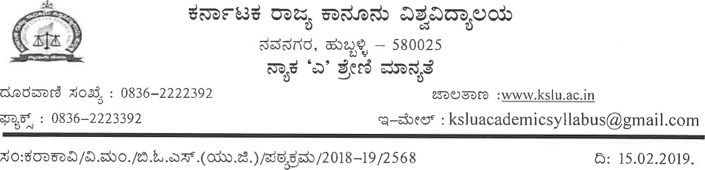
aao±: | e ^{e}ådažöd Ëò0Cò.
:êdöœa
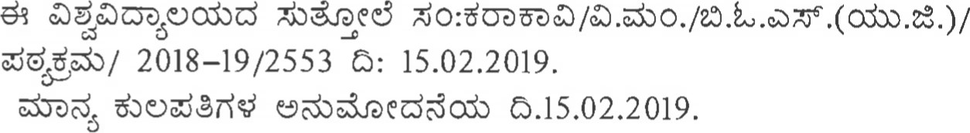
ne.3eD: l. adacnoodòd
2

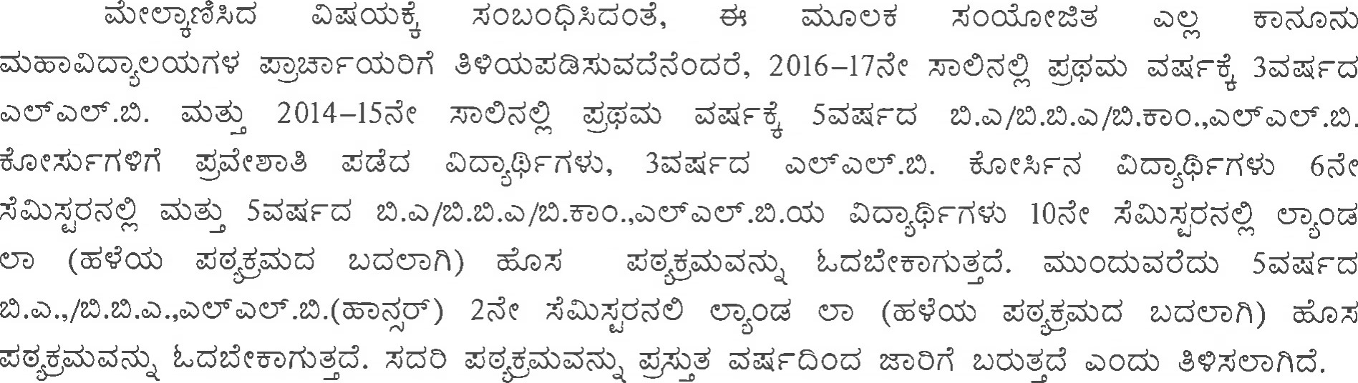
 |  |  | 
01 | 2016-17 | 3dXFd  | 6dk0 |   Appendix-l
02 | 2014-15 | 5dEGc3 | 10 |   Appendix-l
03 |  |  | 2de |   Appendix-l
 d,êodòd)  orfêž)üðñd. sciood OXodòddò sodöð Cd0ò ê?žUðhd.
Soco 


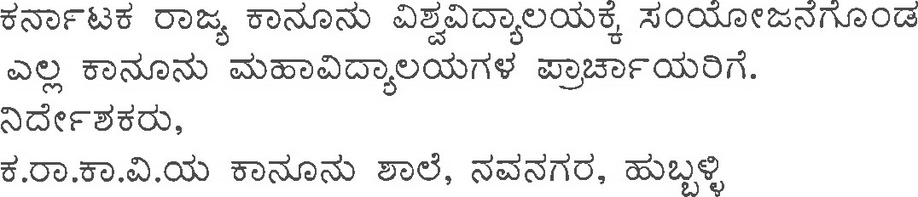
l.
2.

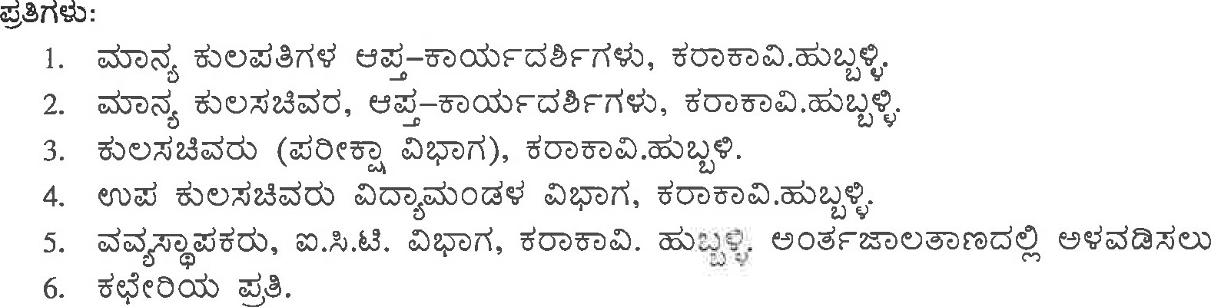
Appendix-I COURSE-IV: OPTIONAL - VI:
LAND LAW
Land plays an important role in the lives of individuals because of which it is elevated to the level of a constitutional status. Of late there is a shift in the approach of the State towards land which is reflected in the laws and their interpretation. Apart from introducing the students to the basic legal regime applicable to land, it is important to introduce them to diverse aspects of land dealings like land revenue, prohibition of transfer, acquisition, conversion, compensation, rehabilitation, resettlement etc. This course is designed towards this end.
UNIT -1
The Right to Fair Compensation and Transparency in Land Acquisition, Rehabilitation and Resettlement Act, 2013- Determination of social impact and public purpose; provision to safèguard food security; notification and acquisition; rehabilitation and resettlement award and procedure.
UNIT -11
The Right to Fair Compensation and Transparency in Land Acquisition, Rehabilitation and Resettlement Act, 20/3—Utilisation, conversion ; National Monitoring Committee; Acquisition, Rehabilitation and Resettlement Authority; apportionment of compensation and payment of compensation.
UNIT -111
The Karnataka Land Revenue Act 1964- Revenue officers and their procedure, Revenue
Appellate Tribunal, Appeal and Revision, Land and land revenue, Record of rights, realisation of land revenue.
UNIT -IV
The Karnataka Scheduled Castes and Scheduled Tribes (Prohibition of Transfer of Certain Lands)Act, 1978 and Rules 1979
The Karnataka Land Reforms Act, 1961 — general provisions regarding tenancies, conferment of ownership on tenants, ceiling on land holdings, restrictions on holding or transfer of agricultural lands, co-operative farms, fragmentation and consolidation of holdings.
UNIT -V
The Real Estate (Regulation and Development) Act, 2016- registration of real estate project and registration of real estate agents, functions and duties of promoter, rights and duties of allottees, the real estate regulatory authority, the real estate appellate tribunal, offences. penalties and adjudication.
The Karnataka Real Estate (Regulation and Development) Rules, 2017 Books Prescribed.
S.G.Biradar, Land Acquisition- A Paradigm Shift, KAS Officers' Research and Training Institute, Bangalore.
Relevant Statutes and Rules.

COURSE-IV: OPTIONAL - VI:
LAW RELATING TO INTERNATIONAL TRADE ECONOMICS.
Objectives:
International trade has assumed great importance in 2 1 ^{st} century and its regulation under law has become a necessity to prevent exploitation of the weaker people. A new legal regime to regulate international trade is emerging. Students of law should have understanding of these developments. This course is worked out to provide the future lawyers basic inputs in the area of international trade law. Course contents:
UNIT 1
Historical perspectives of International Trade, Institutions - UNCTAD, UNCITRAL, GATT (1947-1994); World Trade Organization-Objectives, Structure, Power; Most Favored Nation Treatment and National Treatment; Tariffs and Safeguard measures.
UNIT
Technical Barriers to Trade; Sanitary and Phyto- sanitary measures; Trade Related Investment Measures(TRIMs); Anti- Dumping, Subsidies and Countervailing Measures; Dispute Settlement Process.
UNIT 111
International Sales of Goods Formation and Performance of International Contracts, Various Forms and Standardization of Terms; Acceptance and Rejection of Goods, Frustration of Contract, Invoices and packing, Product liability.
UNIT IV
Exports Insurance of Goods in Transit; Marine Insurance and kinds; Law on Carriage of goods by sea, land and air, Container transport, Pre-Shipment Inspection; Licensing of Export and Imports.
UNIT V
Laws Governing Finance and Investments; Foreign Collaboration and Investment Policy; Foreign Direct Investment in Industries and Governing Policies; Foreign Institutional Investors Investment by Non-resident Indians (NRIs) and Overseas Corporate Bodies (OCBs); Foreign Collaboration Agreement- Foreign Technology Agreement; Foreign Companies and Foreign Nationals in India.
Prescribed Books:
Kaul A.K., Guide to the WTO and GATT: Economics, Law and Politics, (Kluwer Law International , 2006)
Note: The course teacher should down load the latest materials from the net and impart the information to the students.
COURSE-V•. CLINICAL COURSE-IV:
MOOT COURT EXERCISE AND INTERNSHIP
Objectives:
This course is designed to hone advocacy skills in the students. Moot Courts are simulation exercises geared up to endow students with facility in preparation of written submissions and planning, organising and marshalling arguments in the given time so as to convince the presiding officer.
The students should familiarize themselves with the various stages of trial in civil and criminal cases. They should be exposed to real court experience. Further they should imbibe the skills of client interviewing. This component may be planned to be part of the internship. Each student enrolled in 3 year course shall undergo an internship for minimum 12 weeks (20 weeks for 5 year LL.B. course) during the entire course under NGO, trial and appellate advocates, legal regulatory authorities, legislatures and parliament, other legal functionaries, market institutions, law firms, companies, local self government and other such bodies as the university may stipulate. However, the internship shall not be for a period of more than four weeks continuously in an academic year.
Course contents:
Moot Court (30 marks)
1.1 Each student shall participate in at least 3 moot courts. Each Moot court exercise shall carry
10 marks, which shall be divided as under:
for oral advocacy: 5 marks, and Written submission: 5 marks.
1.2 The student shall make written submission on behalf of the party for whom he makes oral advocacy as assigned by the course teacher.
1.3 The written submissions for the three moot courts shall be neatly written on one side of the bond size papers and bound together with a certificate signed by the course teacher and the principal to the effect that it is the bonafide work of the concerned student.
1.4 The cover shall indicate the name of the examination, subject, seat number and the center code number.
Observation of Trial (30 marks)
1.1 Each student shall attend trial in two cases one civil and one criminal in the course of last two or three years.
1.2 The student shall maintain a record and enter the various steps observed during their attendance on different days in the Court.
1.3 The record shall be neatly written on one side of the bond size paper and bound. It will carry a certificate by the course teacher and principal to the effect that it is the bonafide work of the concerned student.
- .4 The record shall be valued for 30 marks.
1.5 The cover page shall indicate the name of the examination, subject, seat number and the center code number.
Client Interviewing (30 marks)
Each student shall observe two session of client interviewing at the Lawyer's Office/Legal Aid Office and record the proceedings in a diary, which shall carry 15 marks.
Each student shall further observe the preparation of documents and Court papers by the Advocate and the procedure for the filing of the suit/petition. This shall be recorded in a diary, which shall carry 15 marks.
The Diaries shall be neatly written on one side of bond size papers and bound with a certificate signed by the course teacher and the Principal to the effect that it is the bonafide work of the concerned student.
The cover page of the diary shall indicate the name of the examination, subject, seat number, and the center code number.
Viva (10 marks)
At the end of the semester, the student shall appear for a viva voce, which shall carry 10 marks.
Method of assessment: The submissions of Moot courts shall be valued by the course teacher. The diaries relating to trial observation and client interviewing and pre-trial preparations shall be valued by the professional under whose supervision the student has completed internship and the course teacher if it is so planned. If internship is with an Authority wherein trial observation and client interviewing is not possible, the student shall undertake these exercises separately and it shall be evaluated by the course teacher. The viva shall be conducted by the Principal of the college and the course teacher.

Bhalla. Raj, International Trade Law: Theory and Practice, 2 d Edition,( Lexis Nexis, 2001)

